Diamante blockchain holdings llc | Delaware, USA
PayCircle API Documentation
Paycircle individual - web
2023

Table of Contents
Table of Contents 1
Sign-Up 3
Sign In 11
Deposit 12
Wire & International Wire Deposit 15
ACH Deposit 16
Transfer 20
Transfer PayCircle to PayCircle 23
Later 25
One Time Payment 25
Recurring Payment 27
Transfer PayCircle to Others 29
PayCircle to others For Domestic ACH 29
Now 33
Later 34
One-Time Schedule Payment 35
Recurring Schedule Payment 36
PayCircle to others For Domestic WIRE 38
Now 39
Later 40
One-Time Schedule Payment 40
Recurring Schedule Payment 42
PayCircle to others For International Wire 44
Now 47
Later 48
One-Time Schedule Payment 48
Recurring Schedule Payment 50
Withdraw 51
Withdraw for ACH 51
Withdraw for Wire 56
Withdraw for International Wire 58
Trade - Buy 63
Trade - Sell 65
Transaction History 67
Scheduled Payments 69
Manage Beneficiary 71
Wallet Details 74
Dashboard 75
Settings 75
Support 84
Notifications 85
Profile 86
Dashboard Search 90
Logout 90

PayCircle Individual Documentation

PayCircle Individual URL: https://pay.paycircle.io/
PayCircle API Documentation Link: https://apidev.paycircle.io:444/swagger-ui/index.html

Sign-Up

- We are adding mobile numbers for the first time. It will check location and it will check for whether a mobile number exists as a PayCircle Account or not by using API v1/sign-in/check-mobile-exists.

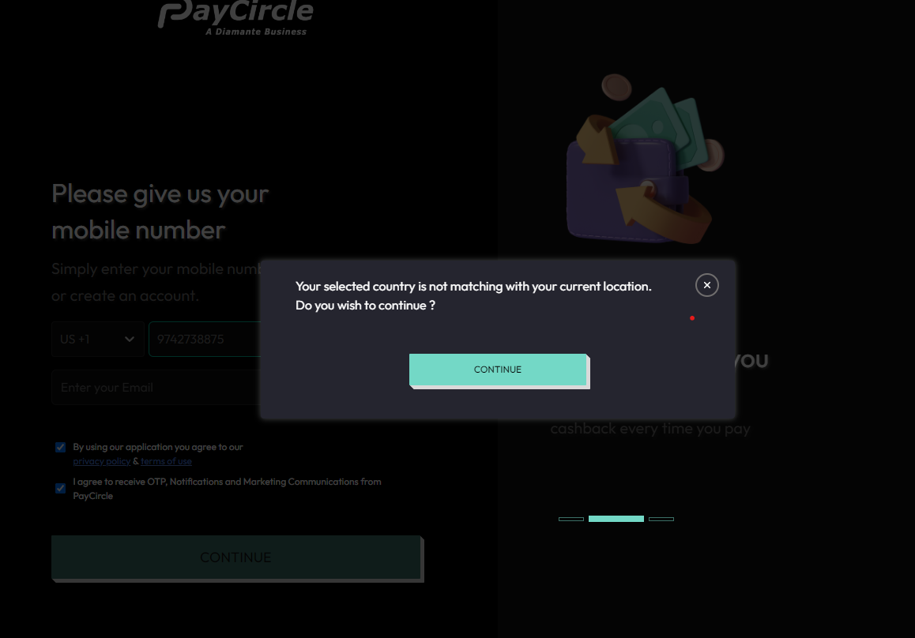

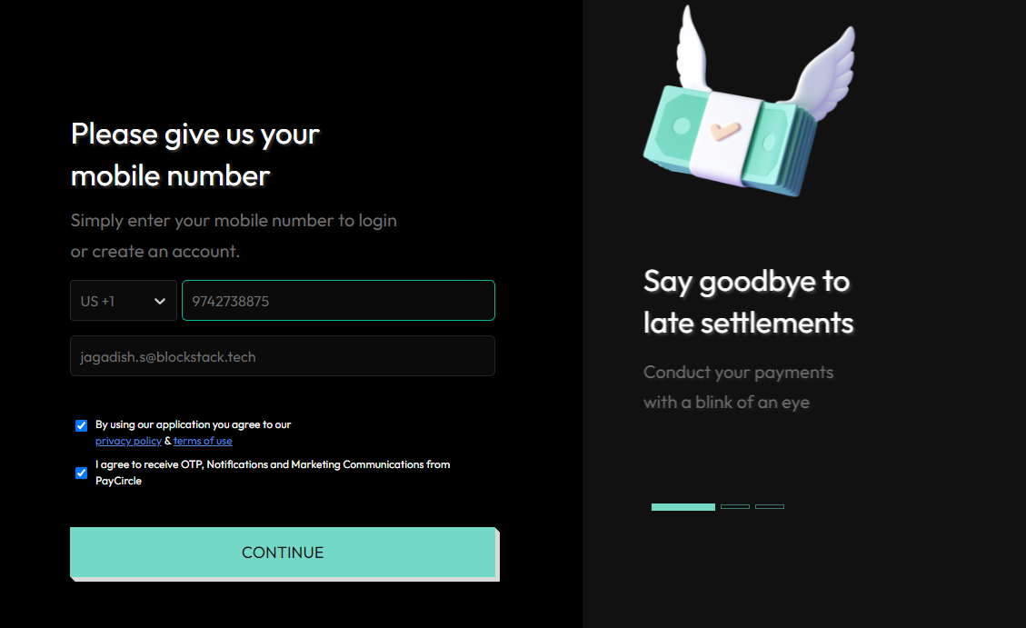

- Now after entering email Id we have to click on the continue button and we will receive otp to both mobile number and email. We enter the otp API which is called v1/mOtp API.

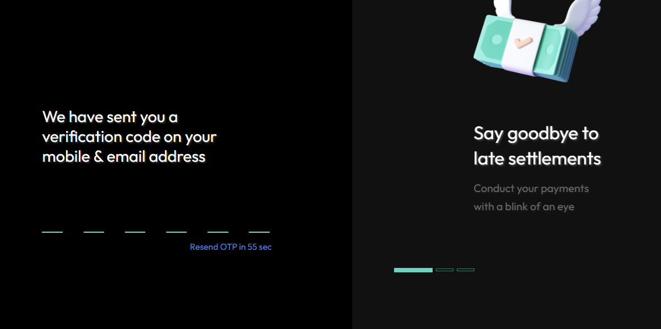

- Now we have to enter otp from email so that it will allow us to create an account.

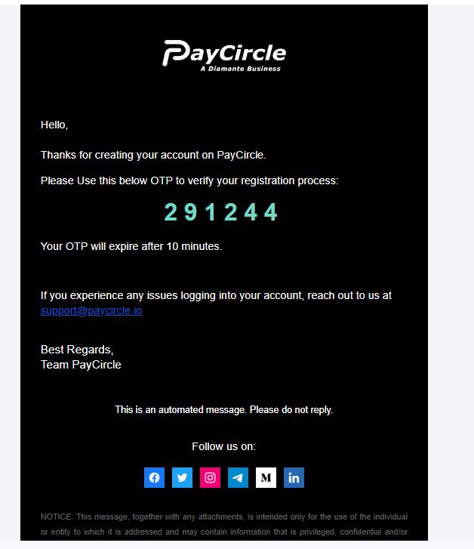

- Now we have to create a password to register a PayCircle account.

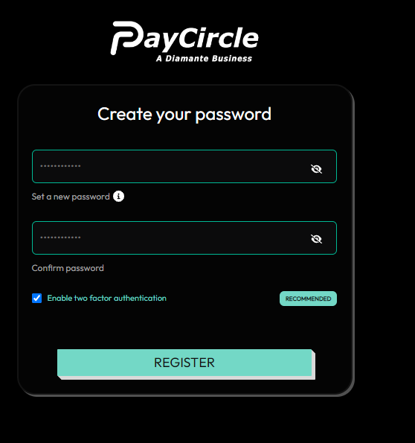

- After entering the password and if the user want to enable 2 factor authentication we have to Scan QR code in google authenticator the API which is called is v1/sign-up API else without enabling 2FA user can register.

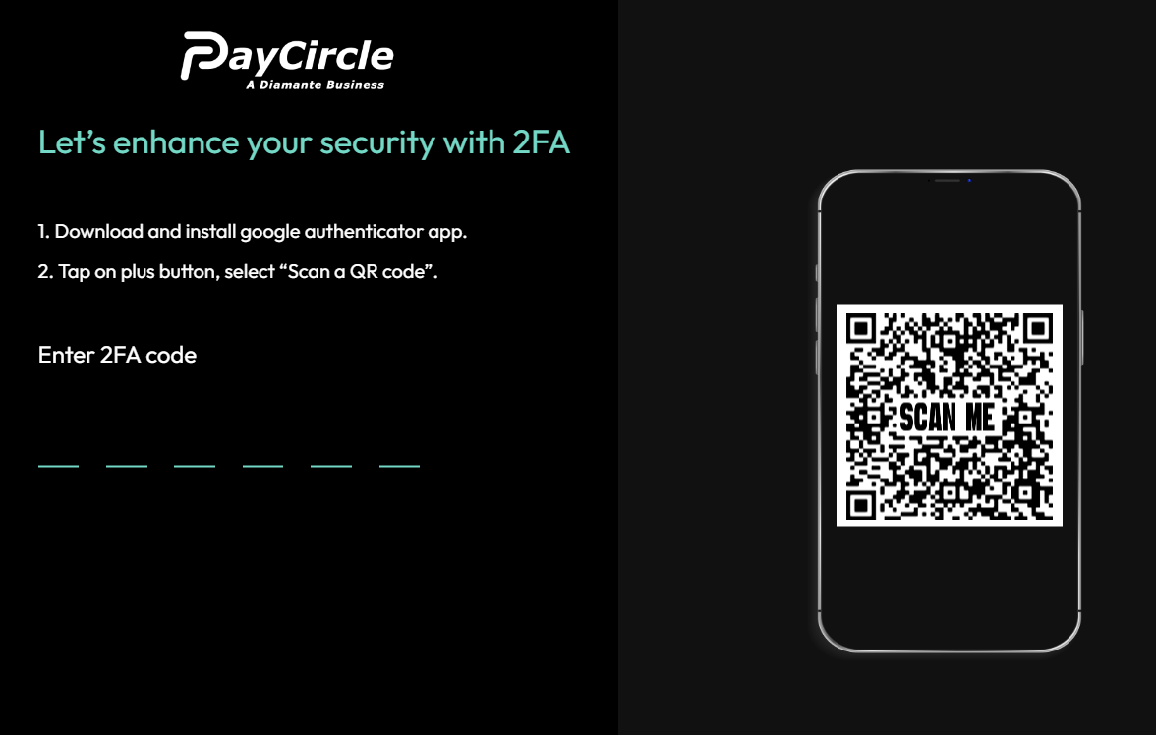
- After entering the code it will confirm v1/confirm2Fa API.
Mobile:
For Uploading front image it will call /API/uploadFrontImage, For back image it will call /API/uploadBackImage and for selfie it will call /API/uploadSelfieImage APIs.
Web:
For Uploading front image it will call socketStream/API/uploadFrontImage, For back image it will call socketStream/API/uploadBackImage and for selfie it will call socketStream/API/uploadSelfieImage APIs.

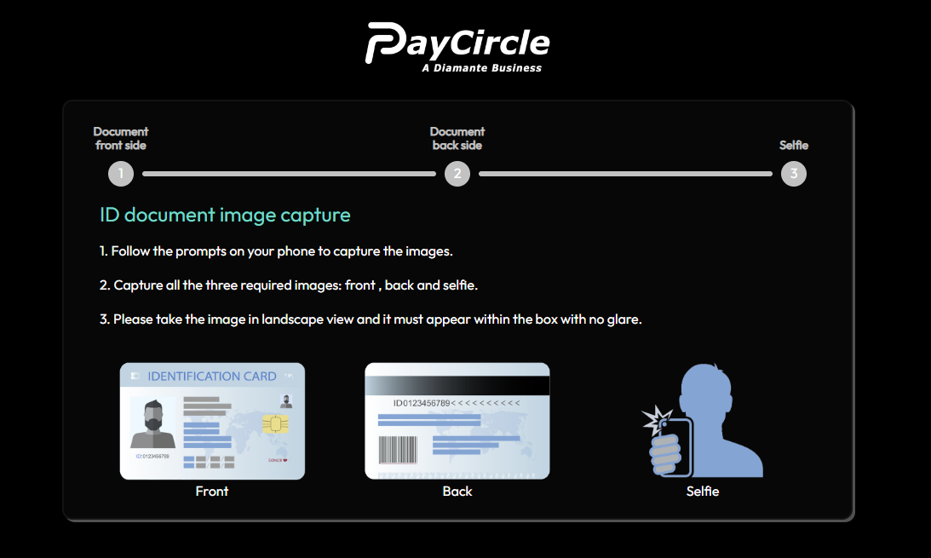

- After uploading the front image, back image and selfie for document verification it will redirect us to the personal information page and filling details it will call v1/insert-personal-info API.

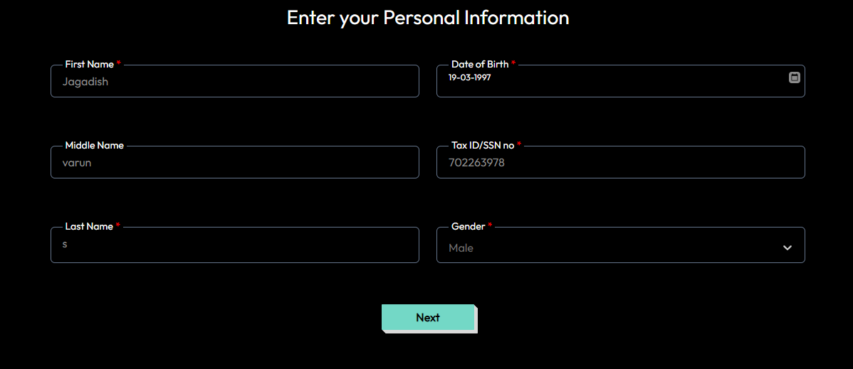
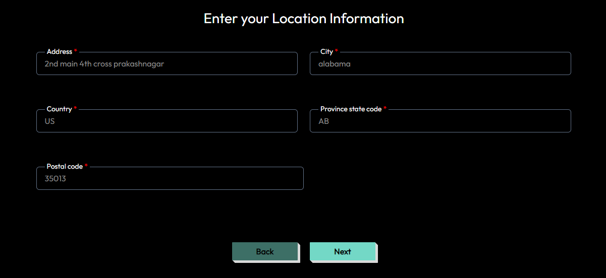

- After filling the location details it will call v1/verify-user-details/kyc/{customerId} API.

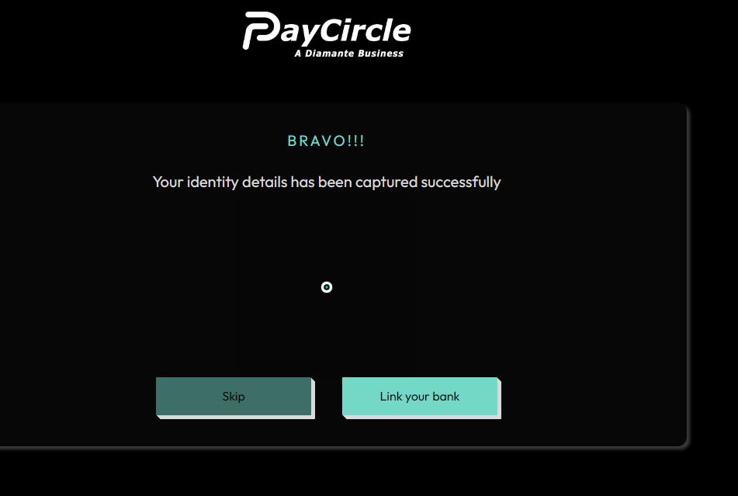

- Next we have click on link your bank internally it will call plaid API’s for linking bank accounts.
- Next we click on the link ‘Link your bank’ internally it will call 3rd party API plaid API /bank/createLinkToken
When acc has been successfully created then it will call /bank/getAccessToken

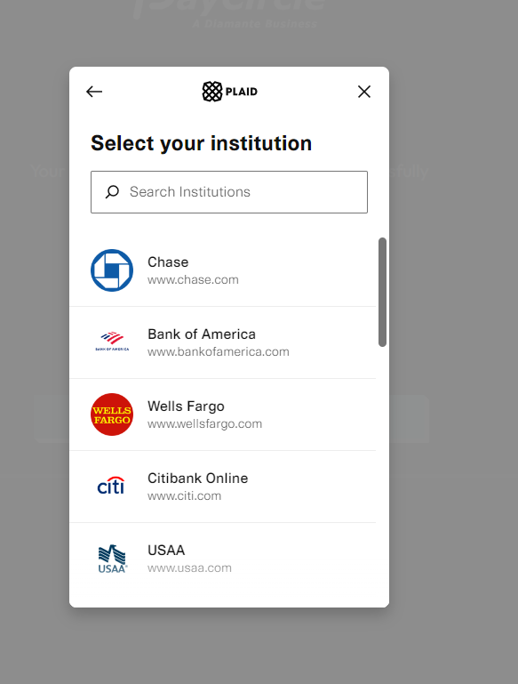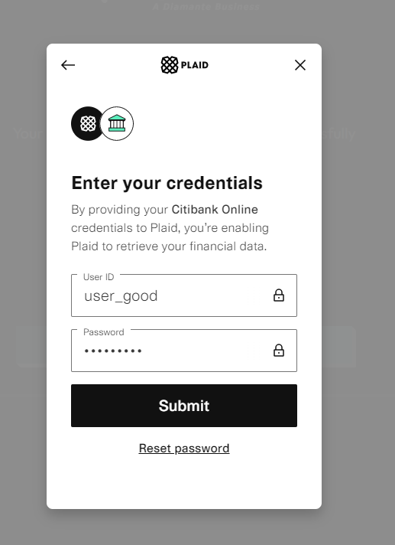

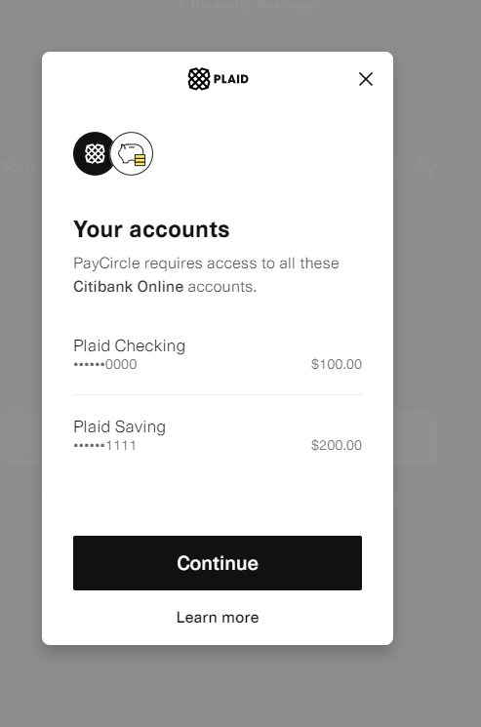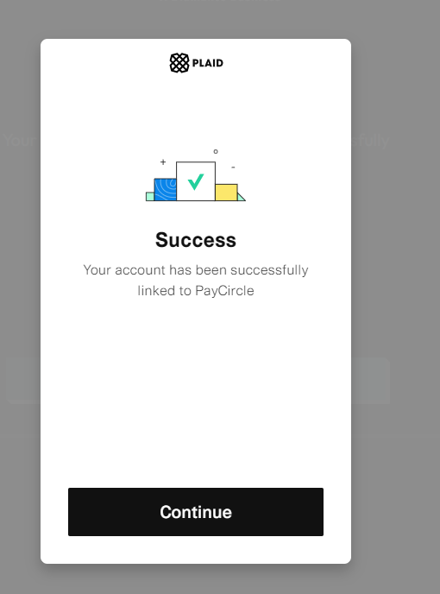

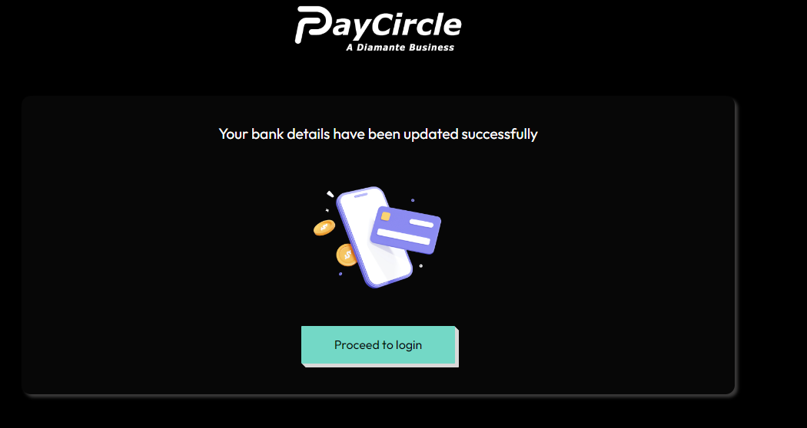

Sign In

- After clicking on proceed to login it will call v1/sign-in API

- If the user has already logged in from one device and tries to login from another device then the below message will be displayed.

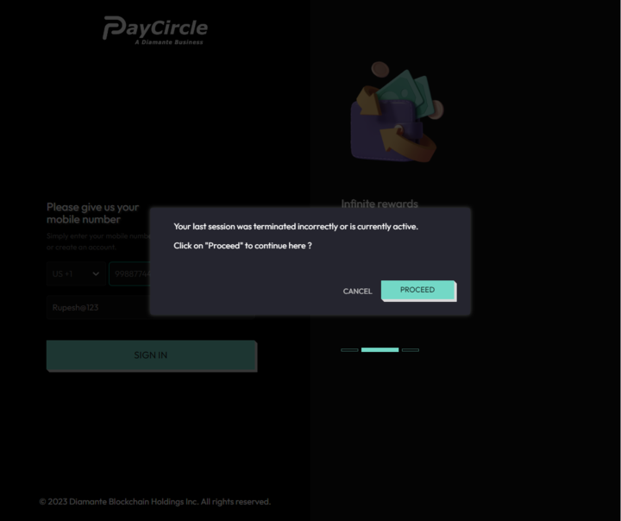
- If the user clicks on proceed then they will be logged out from the previous device and they can access his account from another device. If the user is not already logged in then they can login directly.

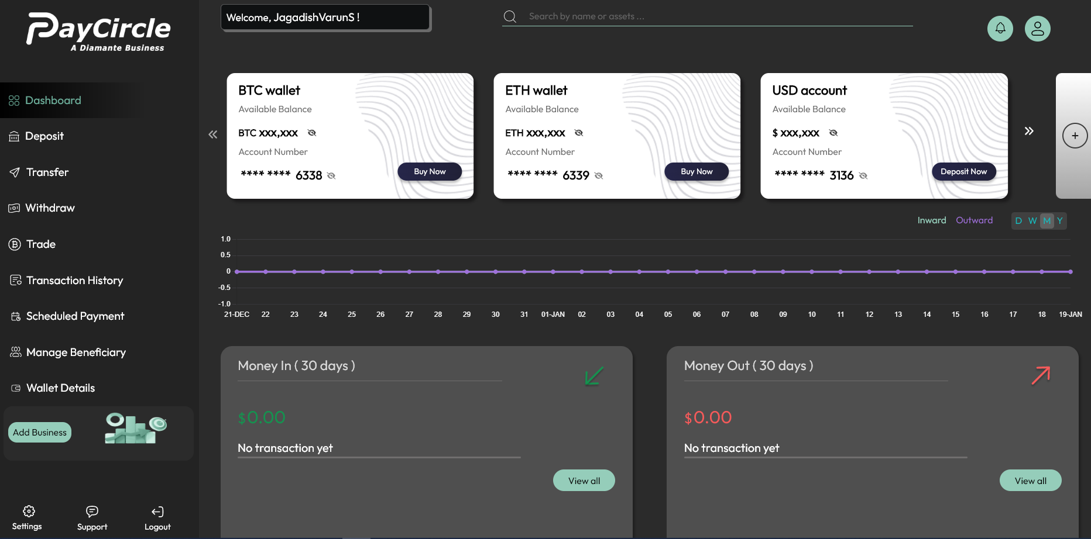
- When you signIn it will call v1/sign-in API along with /payment/v1/get-transaction-history API and /payment/v1/get-transaction-chart API.

Deposit

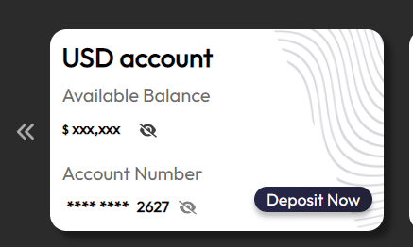
- Clicking on the "Deposit" button triggers the /payment/v1/asset-transfer-methods API.

- Choose the "Credit Card" option and add a credit card if desired. Instructions on how to add a credit card can be found on the settings page.

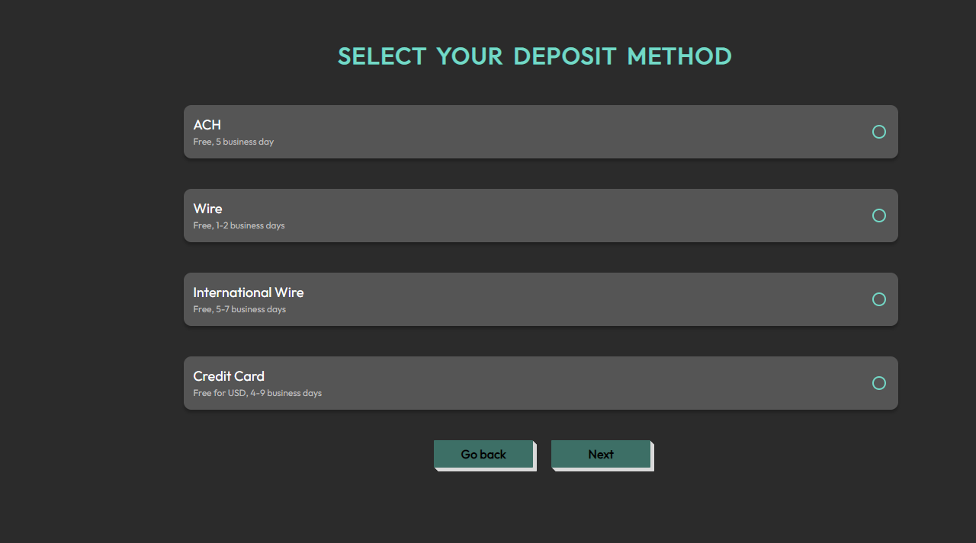

- Clicking on "Deposit" again calls the v1/get-wallet-details/{customerId} API and opens the deposit page.
- Enter the asset name (e.g., USD, USDT, USDC) and it will call the v1/get-asset-details/{assetName}/{transactionType}.vv1/get-asset-details/USD/DEPOSITv1/get-asset-details/USD/DEPOSIT1 /get-asset-details/USD/DEPOSIT API for deposit transactions

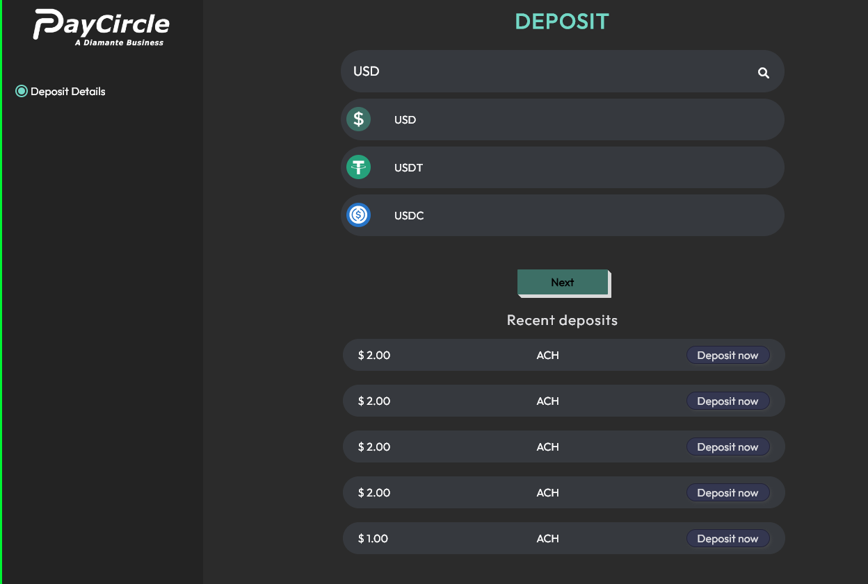

- After entering the asset name, clicking on the "Next" button will call the v1/get-all-fund-transfer-methods API.

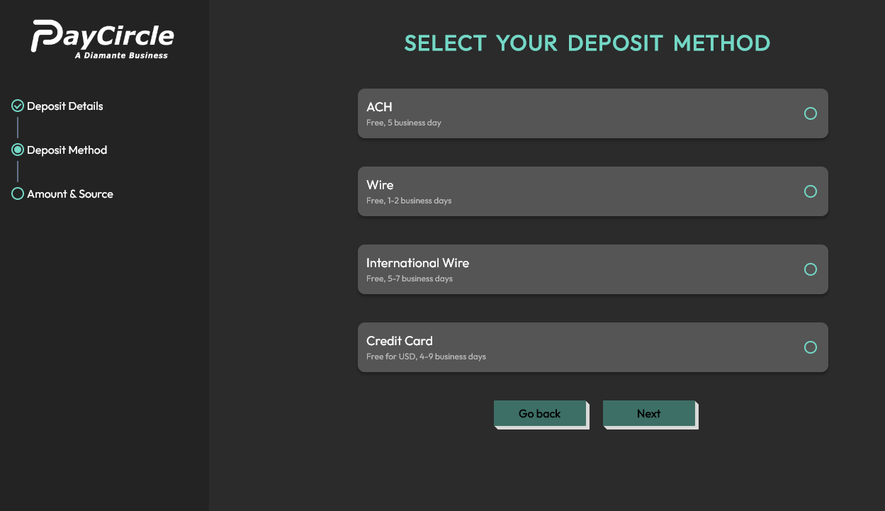

Wire & International Wire Deposit

- To initiate a Wire or International Wire Deposit, click on the respective options and then click on "Next." This will trigger the bank/get-bank-details API.

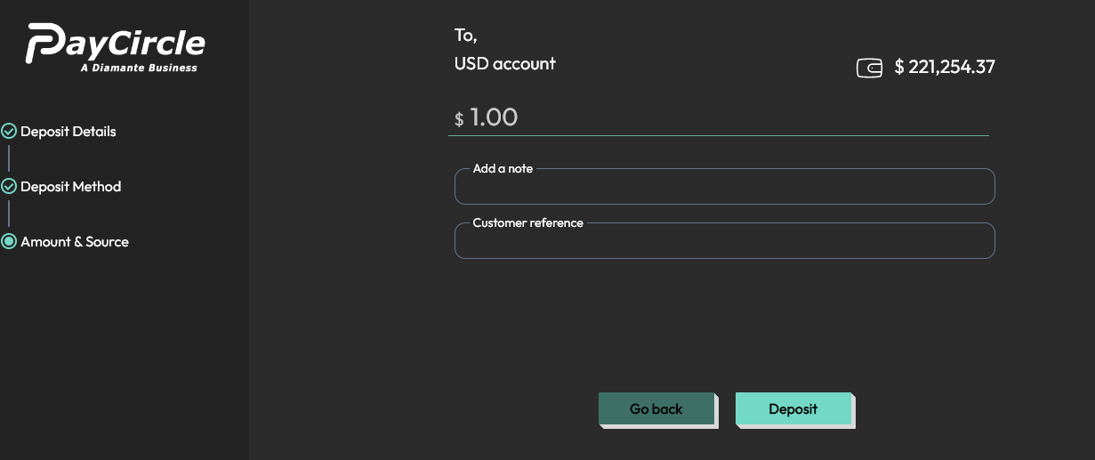

- Once "Deposit” is clicked, the v1/deposit-funds API will be called to deposit the specified amount.

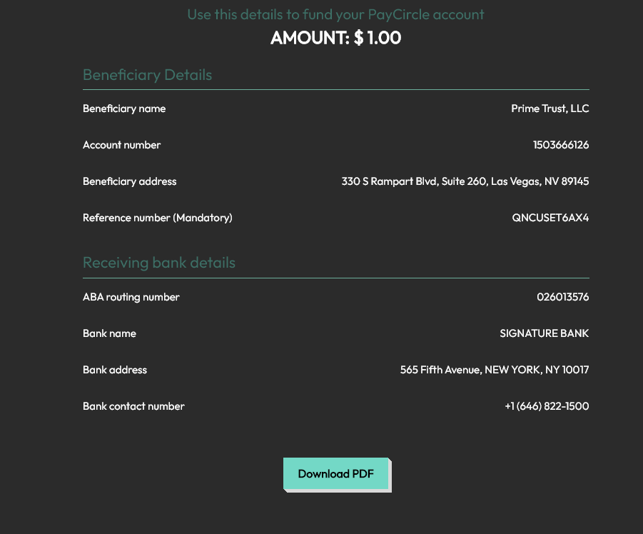

ACH Deposit

- To make an ACH deposit, enter the desired amount and click on "Next."

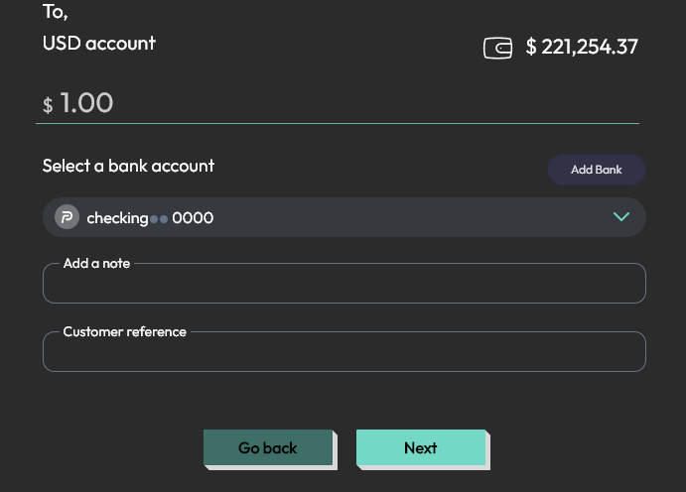

- This will trigger the v1/verify-trans-otp API to generate a 6-digit OTP. After entering the OTP, the v1/deposit-funds API will be called to complete the transaction and deposit the funds.

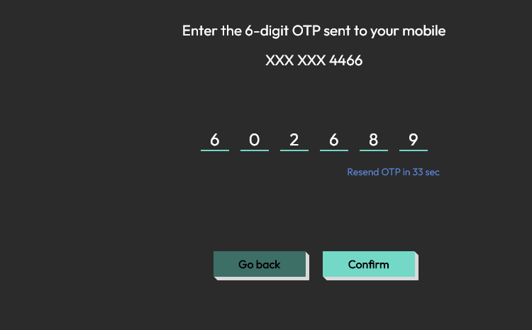

- For Card deposits, you need to specify the amount and add card details.

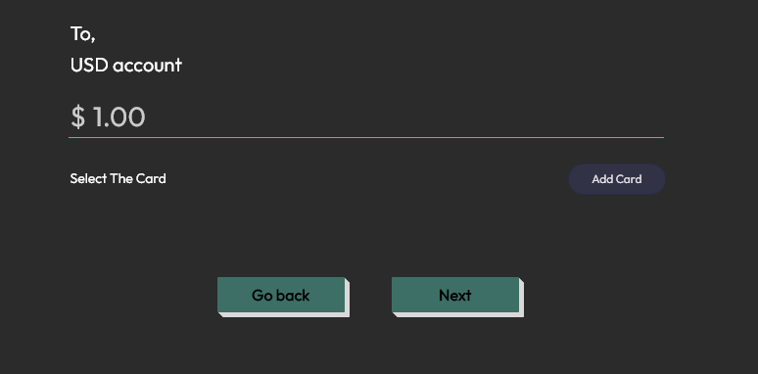

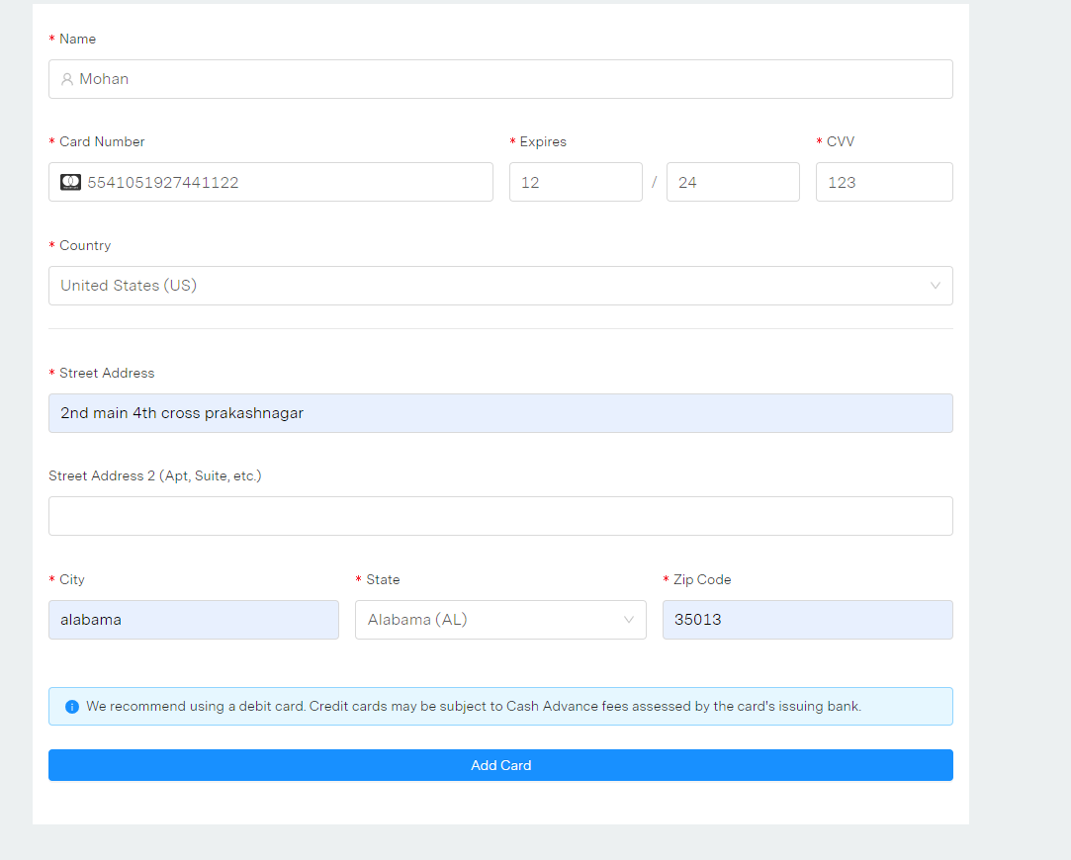
- Clicking on "Add card" will trigger the /bank/insert-credit-card-details/{customerId} API.

- After adding the card, a 6-digit OTP will be generated, which you need to enter to complete the transaction. This will call the v1/verify-trans-otp and v1/deposit-funds APIs to deposit the funds.
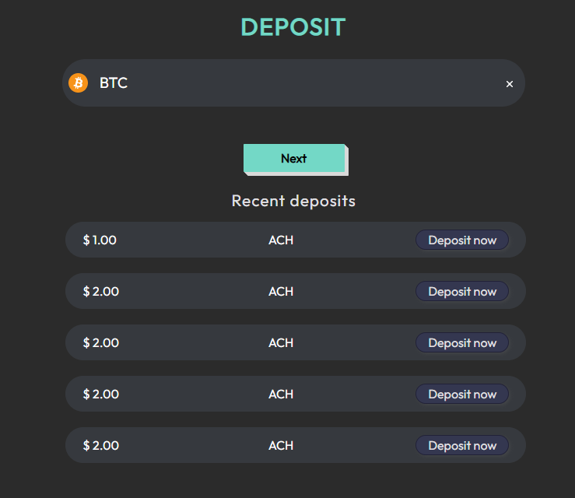

- To deposit using cryptocurrency, select the asset name, and this will call the v1/asset-transfer-methods API to get your BTC wallet.

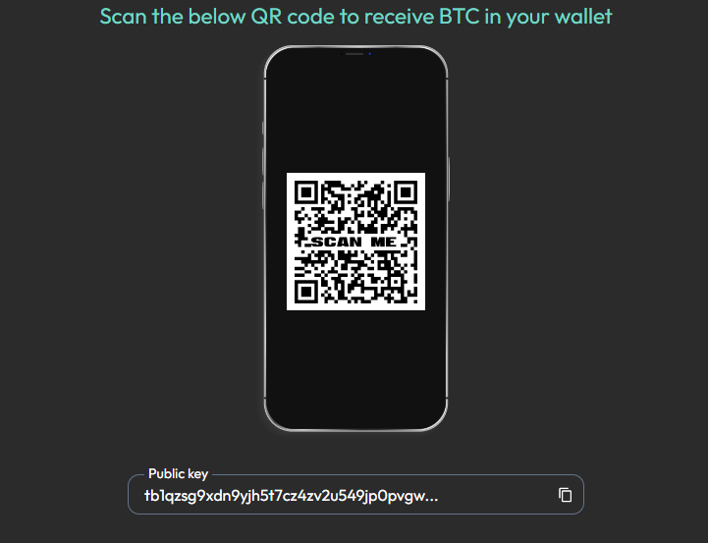

Transfer

- To transfer BTC, navigate to the transfer page.
- On the transfer page, the user needs to enter BTC as the asset name, and provide the receiver's name, email, or mobile number.
- This will allow us to fetch the asset and wallet details by calling the v1/get-asset-details/BTC/Transfer and v1/get-wallet-details/{customerId}/{assetId} APIs.

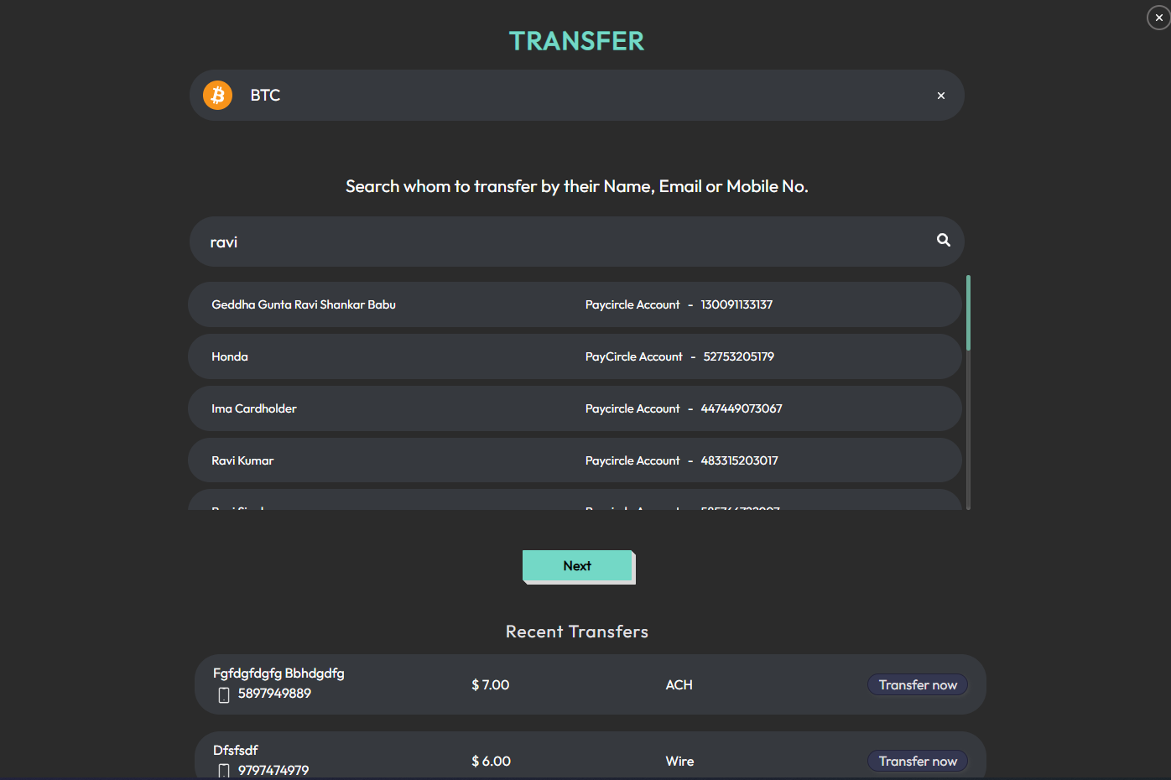

- After entering the asset name, provide the receiver's name, email, or mobile number.
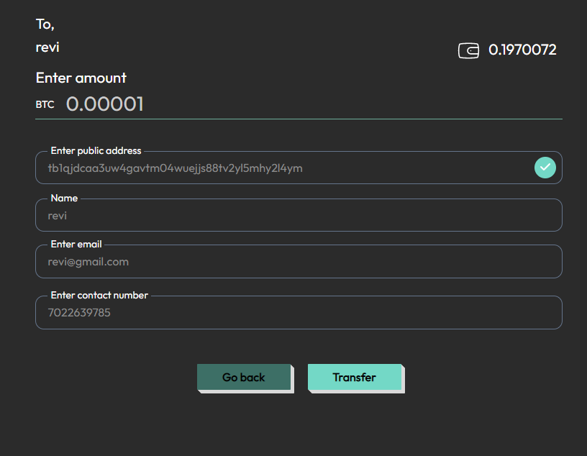
- Next, the user needs to enter the amount of BTC we want to transfer, which will be called the v1/wallet-address-validation API. Once user has filled in the necessary details, they can click on the "Next" button.

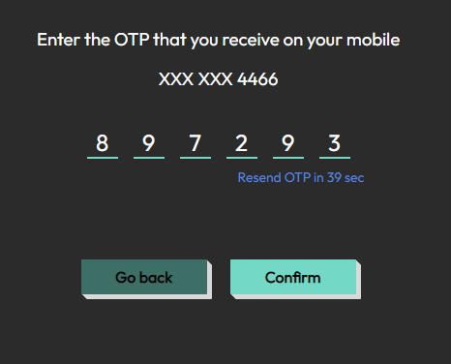

- The user will then be prompted to enter a 6-digit OTP, which will call the v1/verify-trans-otp API. Once the OTP has been verified, the system will call the v1/asset-disbursement-authorizations API, and the transaction will be completed.



Transfer PayCircle to PayCircle

- To transfer USD, enter the asset name and provide the receiver's name, email, or mobile number. This will call the v1/get-wallet-details/{customerId}/{assetId} API. Click on the "Next" button to proceed to the next step.

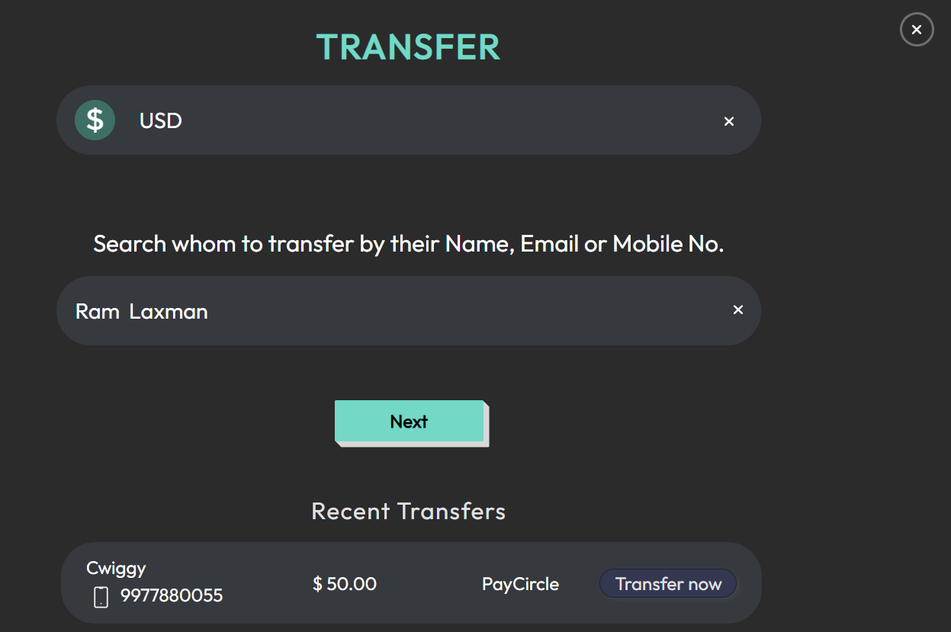

- Enter the amount you want to transfer and click on the "Transfer" button.
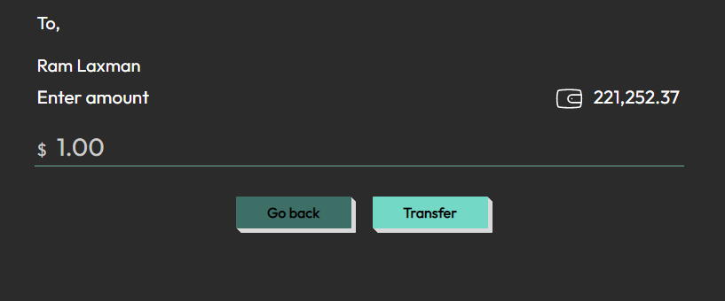

- The user will then be prompted to choose between "Now" or "Later."
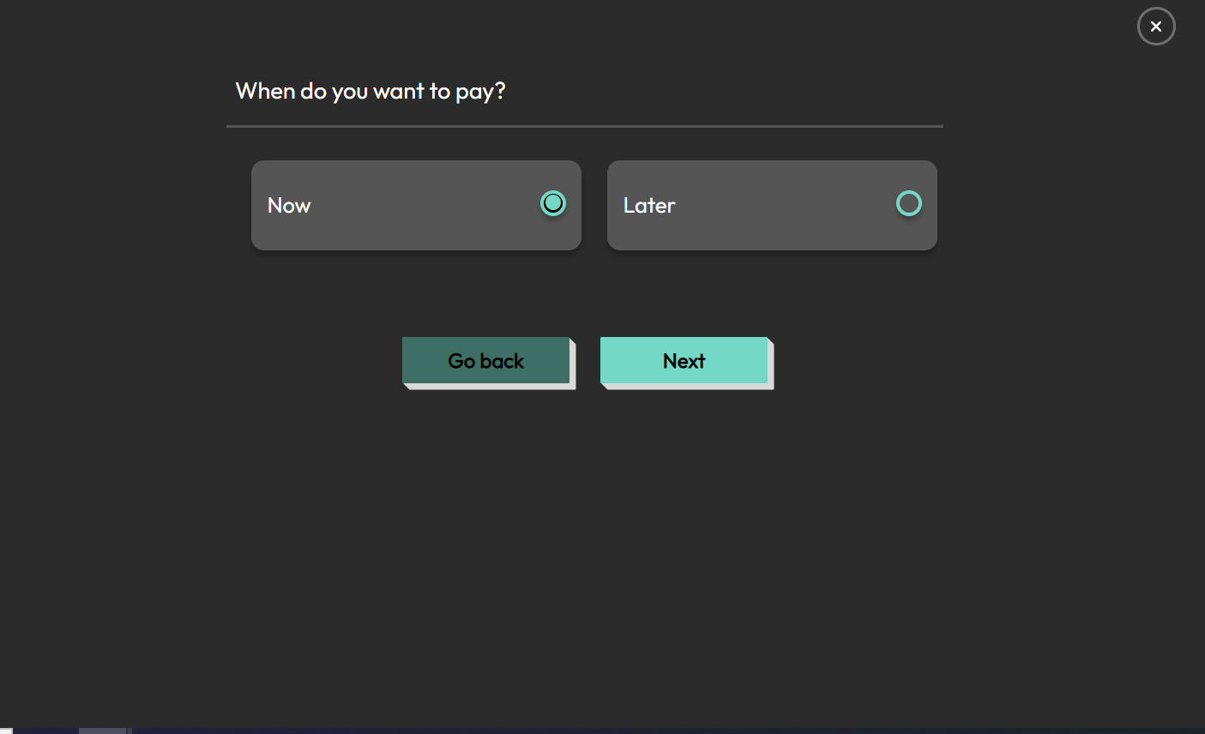
  - Case I: If the user selects "Now," you will be redirected to the One-Time Pin Verification screen, and the v1/verify-trans-otp API will be called once you enter the OTP. .

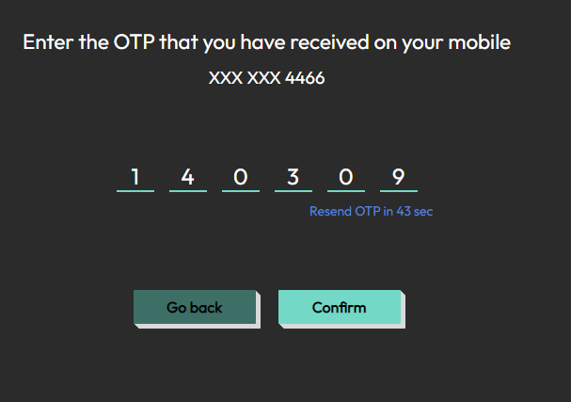
  - After that, the v1/transfer-funds API will be called, and the transaction will be completed.


Later
  - Case II: If they choose "Later," you will be presented with the option to schedule a one-time or recurring payment.

One Time Payment
    - Case i: If you select the one-time payment option, you can choose the date for the future payment and click on the "Next" button.
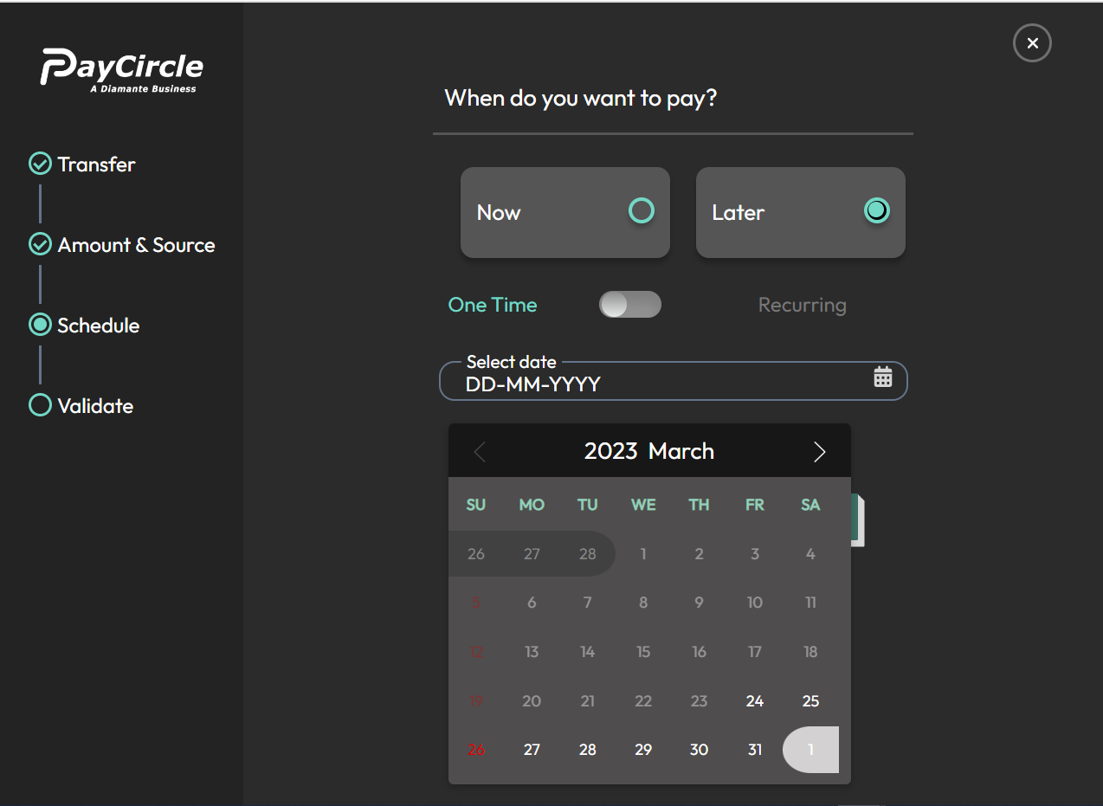
    - You will then be prompted to enter the OTP on the One-Time Pin Verification screen, and the v1/verify-trans-otp API will be called.
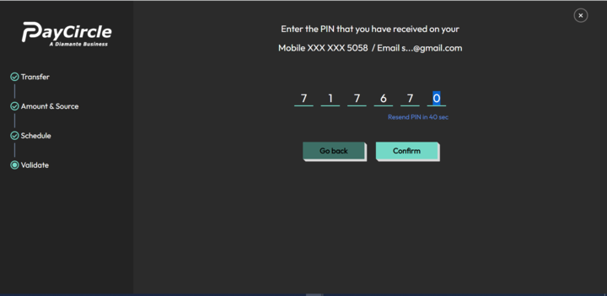
    - Once the user has entered the valid OTP, the v1/customer-schedule-fund-transaction API will be called, and the transaction will be scheduled successfully.

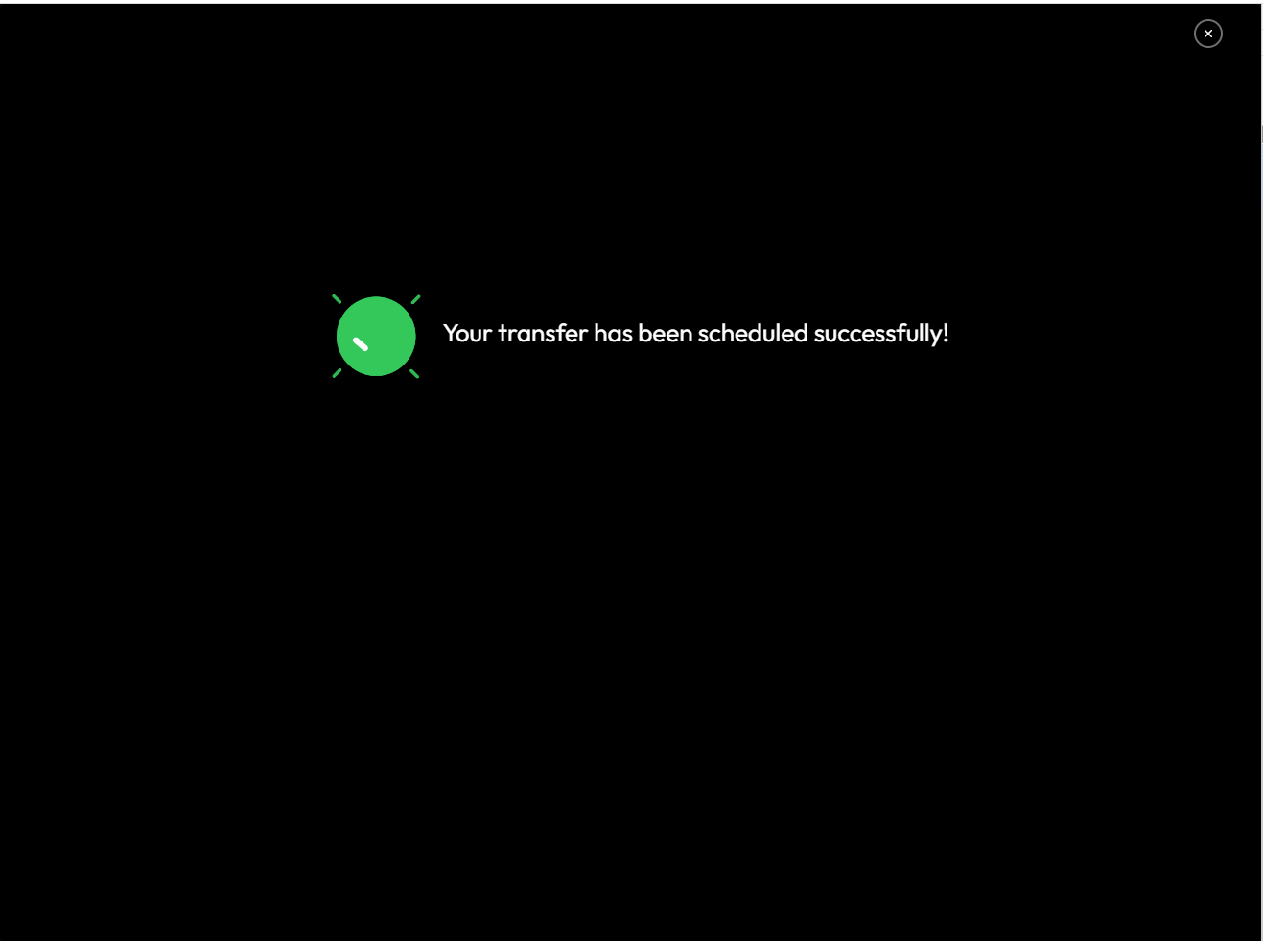

Recurring Payment
    - Case ii : If you choose the recurring payment option, you will need to select the tenure, recurring period, and start date.
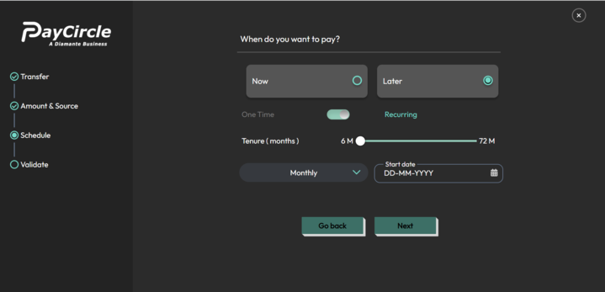
    - After that, click on the "Next" button to proceed. You will then be prompted to enter the OTP on the One-Time Pin Verification screen, and the v1/verify-trans-otp API will be called.
.

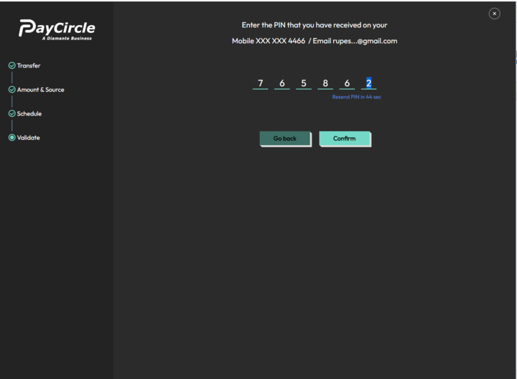
    - Once user has entered the valid OTP, the v1/customer-schedule-fund-transaction API will be called, and the transaction will be scheduled successfully.



Transfer PayCircle to Others

PayCircle to others For Domestic ACH
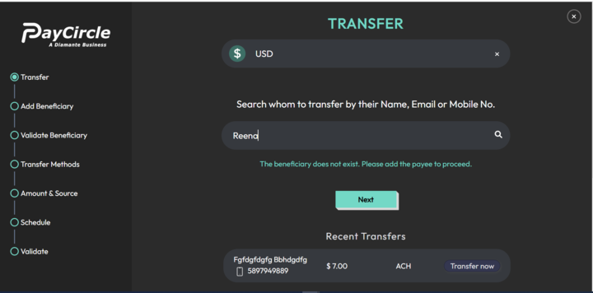

- To initiate a transfer, the user needs to enter the asset name and the receiver's details (such as name, email, or mobile number), and then click on the "Next" button.

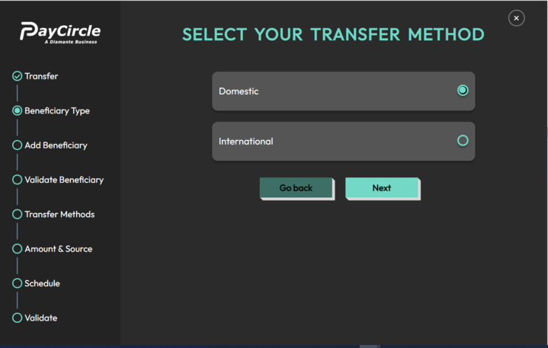

- On the next screen, the user will be presented with the options to select the transfer method. We can choose either Domestic or International, Domestic transfer method is chosen. And then click "Next".
- The user will be prompted to enter the receiver/beneficiary bank and address details. Once done, they can click on "Next".

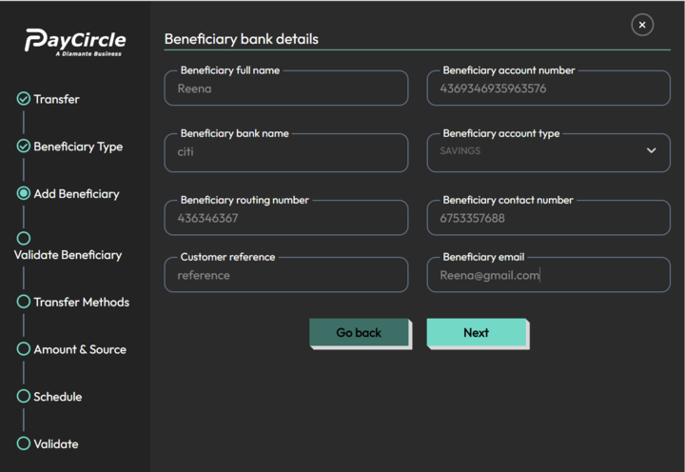

- After entering Bank details & clicking on “Next”..

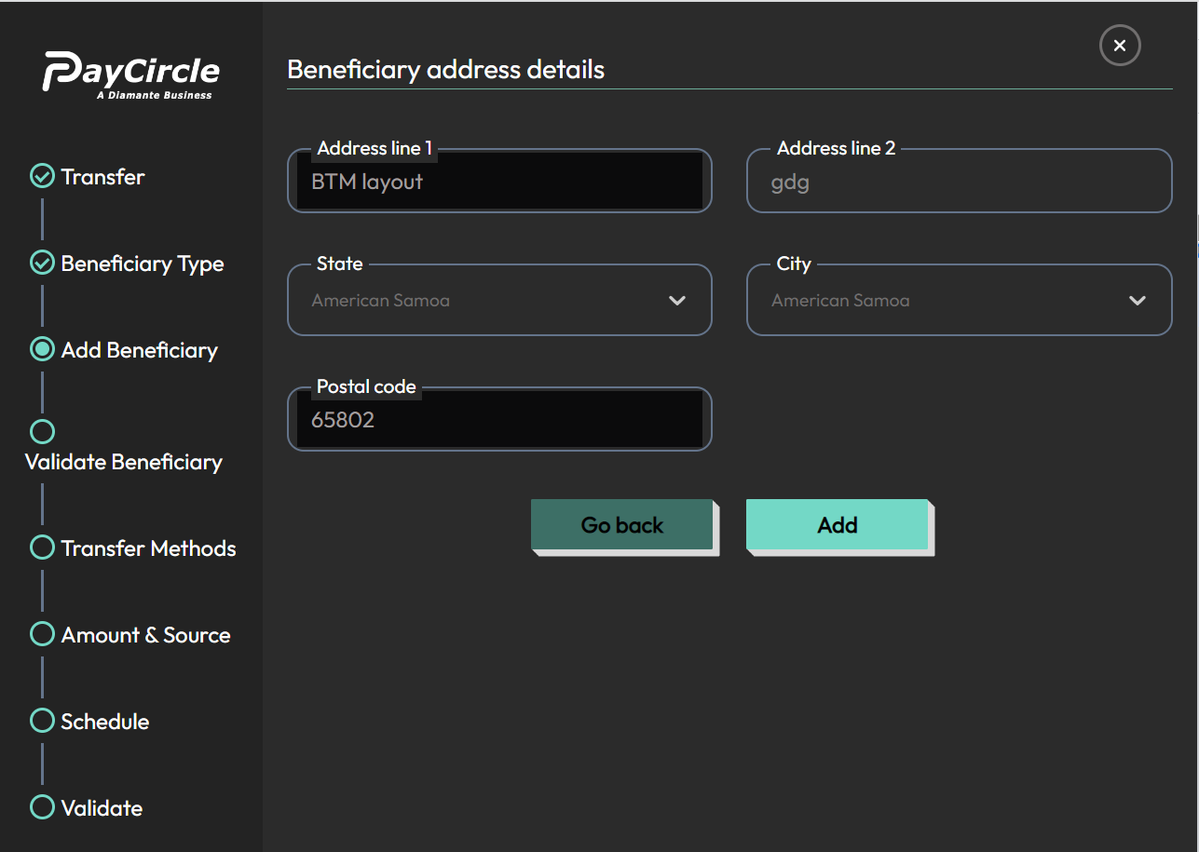

- After entering details & clicking on Add button it will redirect to verify one-time-pin screen for confirmation of addition of beneficiary.
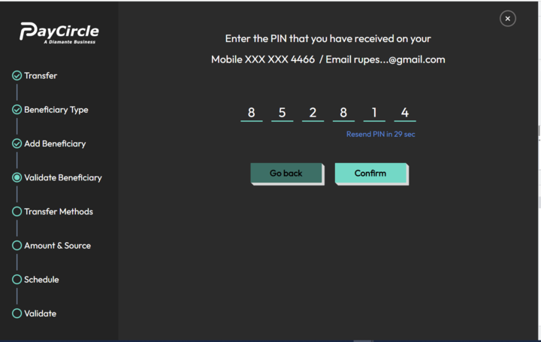

- After entering valid Pin & click on Confirm button then beneficiary details will be added & v1/add-customer-beneficiary API will be called.

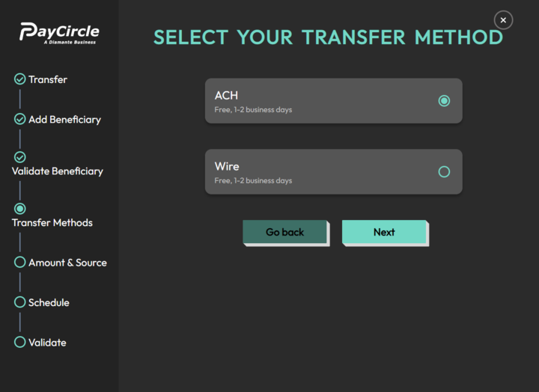
- After adding a beneficiary user gets screen to select any of Domestic transfer methods like ACH or Wire. Here, ACH is chosen.

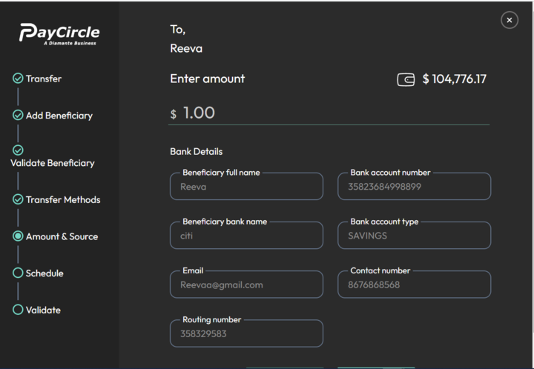

- After entering the amount & verifying receiver details clicking on next.

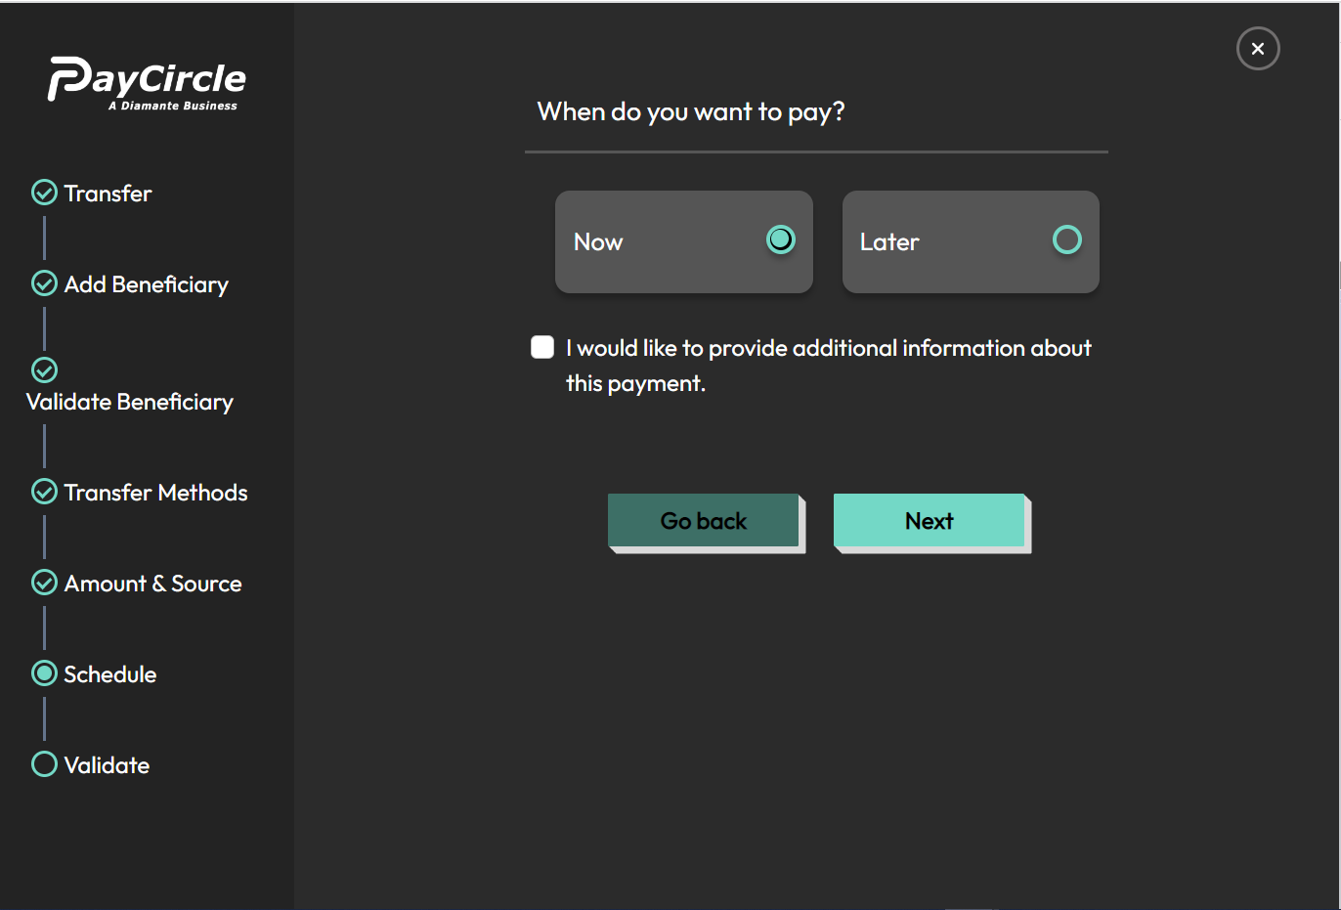

- After clicking on the next user gets the option to pay Now or Later. After selecting & clicking on Next.

Now
  - Case A : After selecting Now & clicking on next the user is redirected to one-time-pin verification screen & v1/verifyTransOtp API is called
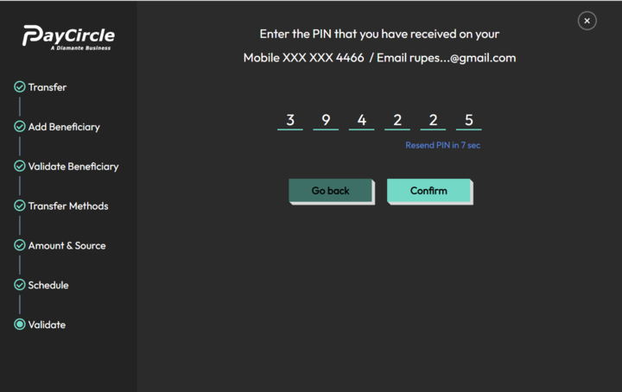

  - After successfully verifying the PIN v1/withdraw-funds API is called.



Later
  - Case B: After selecting Later, the user can select between OneTime & Recurring.
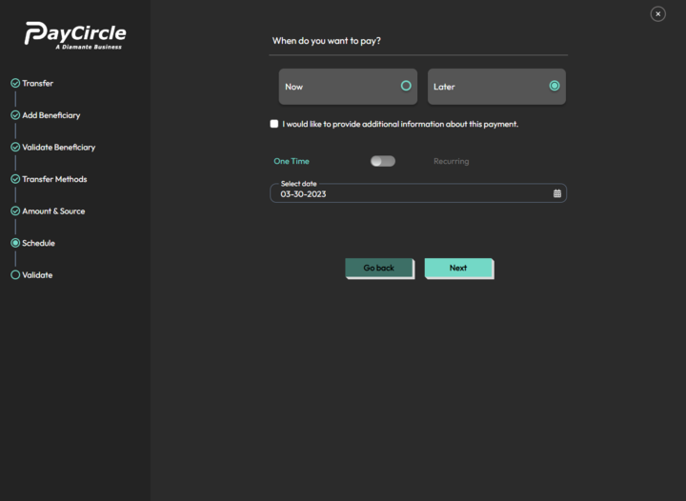

One-Time Schedule Payment
    - Case a: By default one time payment is selected here user can select preferred date to schedule the transaction.
    - After selecting date and Clicking on next user will be redirected to verify One-Time-Pin screen
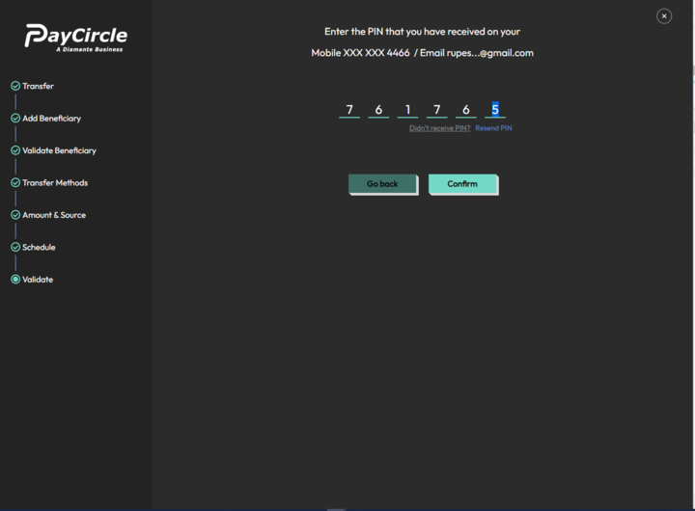
    - After entering valid PIN v1/customer-schedule-fund-transaction will be called & transaction will be scheduled.


Recurring Schedule Payment
- Case b: If a user chooses to pay as recurring payment they get the option to select Tenure, Payment Cycle and Start date.
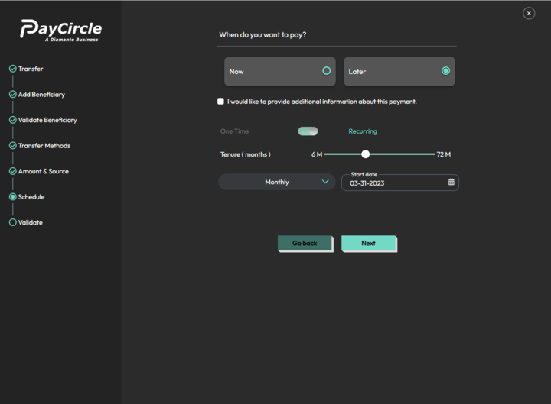
- After selecting all the fields & clicking on “Next”, the user will be redirected to verify One-Time-Pin screen


- After entering valid PIN v1/customer-schedule-fund-transaction will be called & transaction will be scheduled.



PayCircle to others For Domestic WIRE

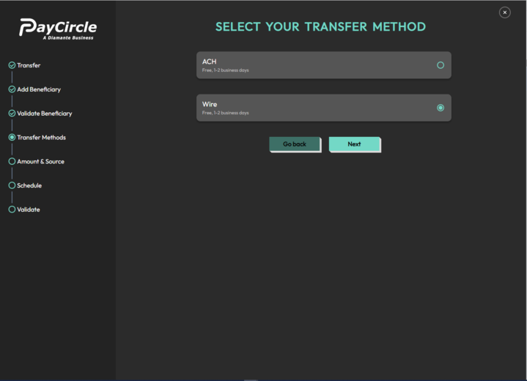

- In domestic transfer when the user chooses to transfer using Wire method & clicks on next.

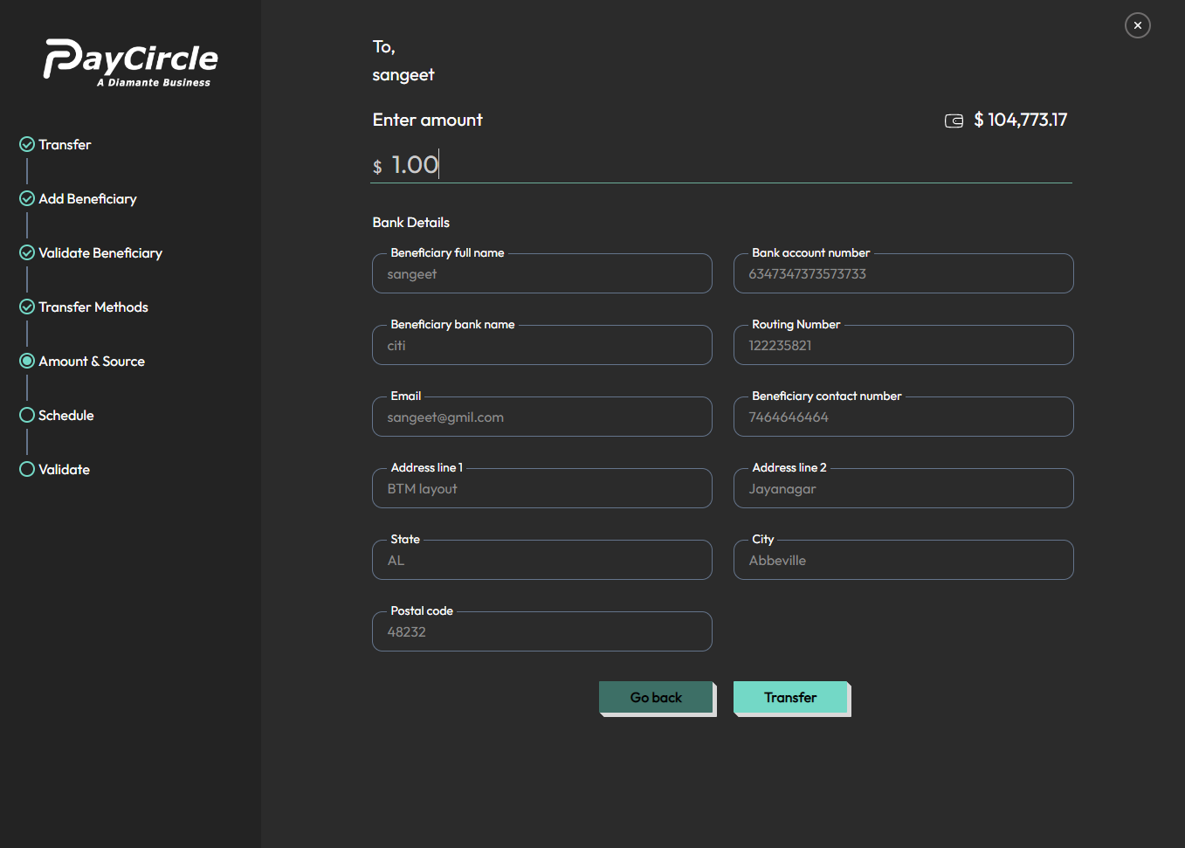
- After clicking next, the user has to enter the amount & receiver’s/beneficiary details and click on the “Transfer”.

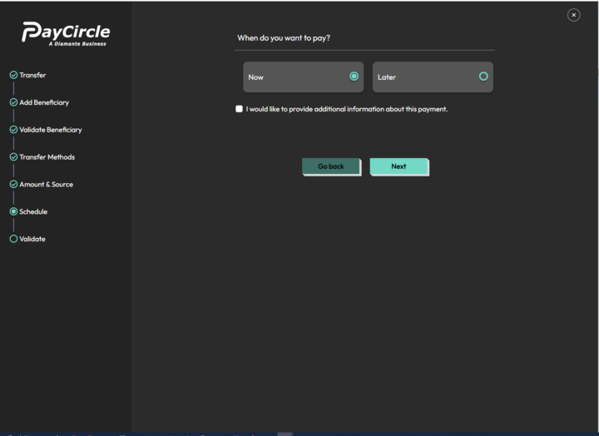
- After clicking on “Transfer”, the user gets the option to either Pay Now or they can schedule the transfer.

Now
- Case I : if user chooses to pay Now & clicks on next then they will be redirected to One-Time-Pin verification screen & v1/verifyTransOtp API will be called.
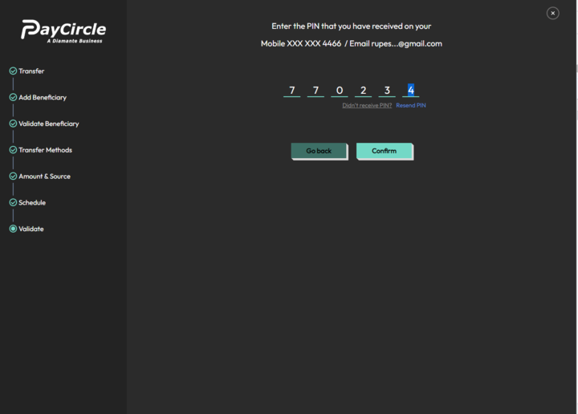
- After entering valid Pin payment/v1/withdraw-funds API will be called & transfer will be initiated.


Later
- Case II: If the user wishes to schedule the transfer then they can schedule either One-time payment or recurring payment.

One-Time Schedule Payment
- Case i: By default one-time payment is selected.
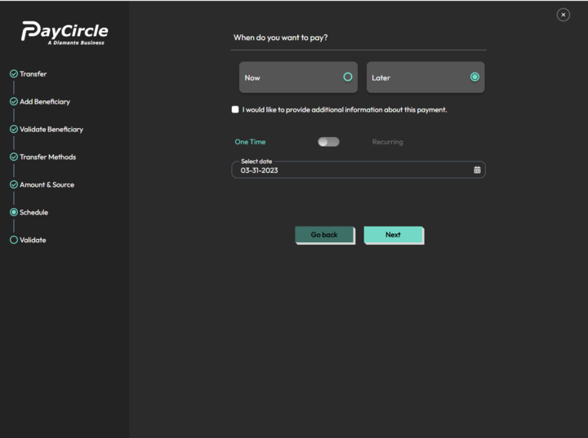

- To schedule a one-time payment, the user needs to select the desired date for the transfer and then click on the Next button.
- The user will then be redirected to a one-time-pin verification screen where the v1/verifyTransOtp API will be called for PIN verification.

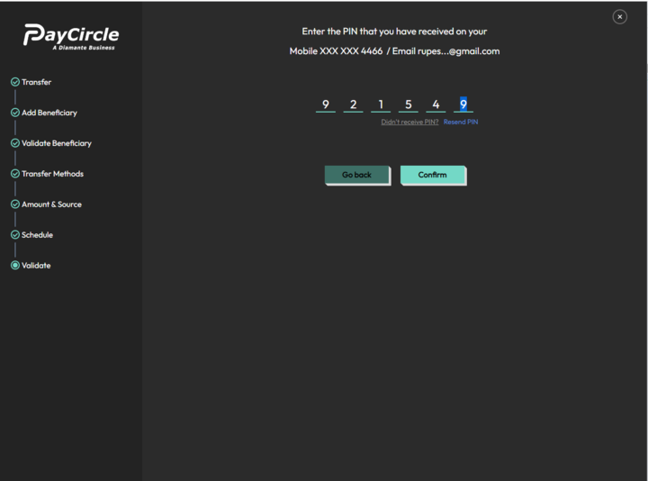
- After entering valid Pin payment/v1/customer-schedule-fund-transaction API will be called & transfer will be scheduled



Recurring Schedule Payment
- Case ii: If the user wishes to schedule recurring payment then they have to select Tenure, Payment cycle & start date. After selecting all the details Click on Next button verify one-time-pin screen will be displayed & payment/v1/verifyTransOtp API will be called

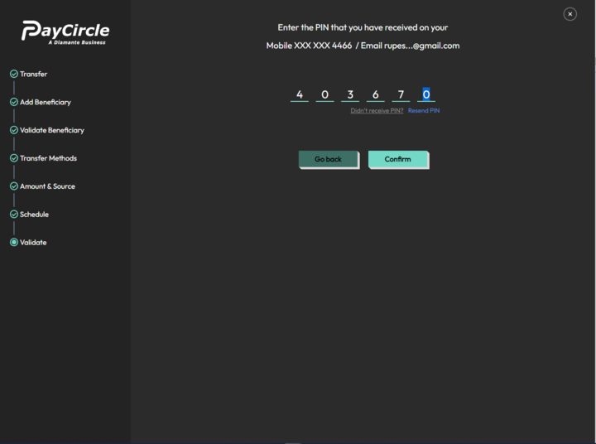
- After entering valid pin user payment/v1/customer-schedule-fund-transaction API is called & transaction is scheduled.



PayCircle to others For International Wire

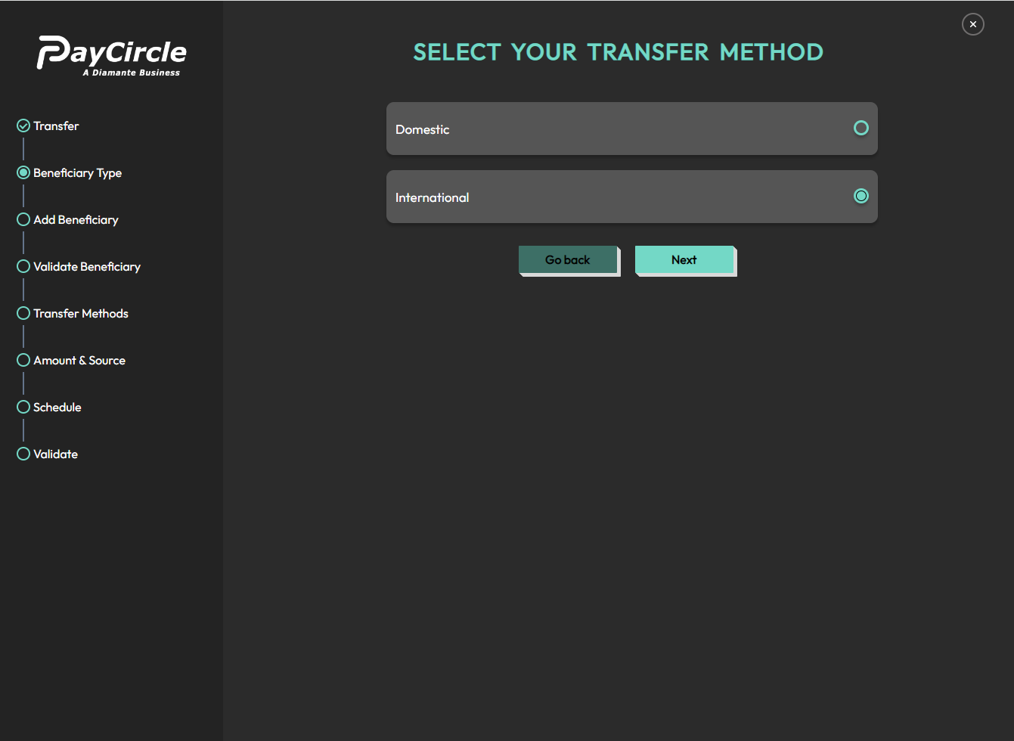
- If the user selects International wire & clicks on Next button.

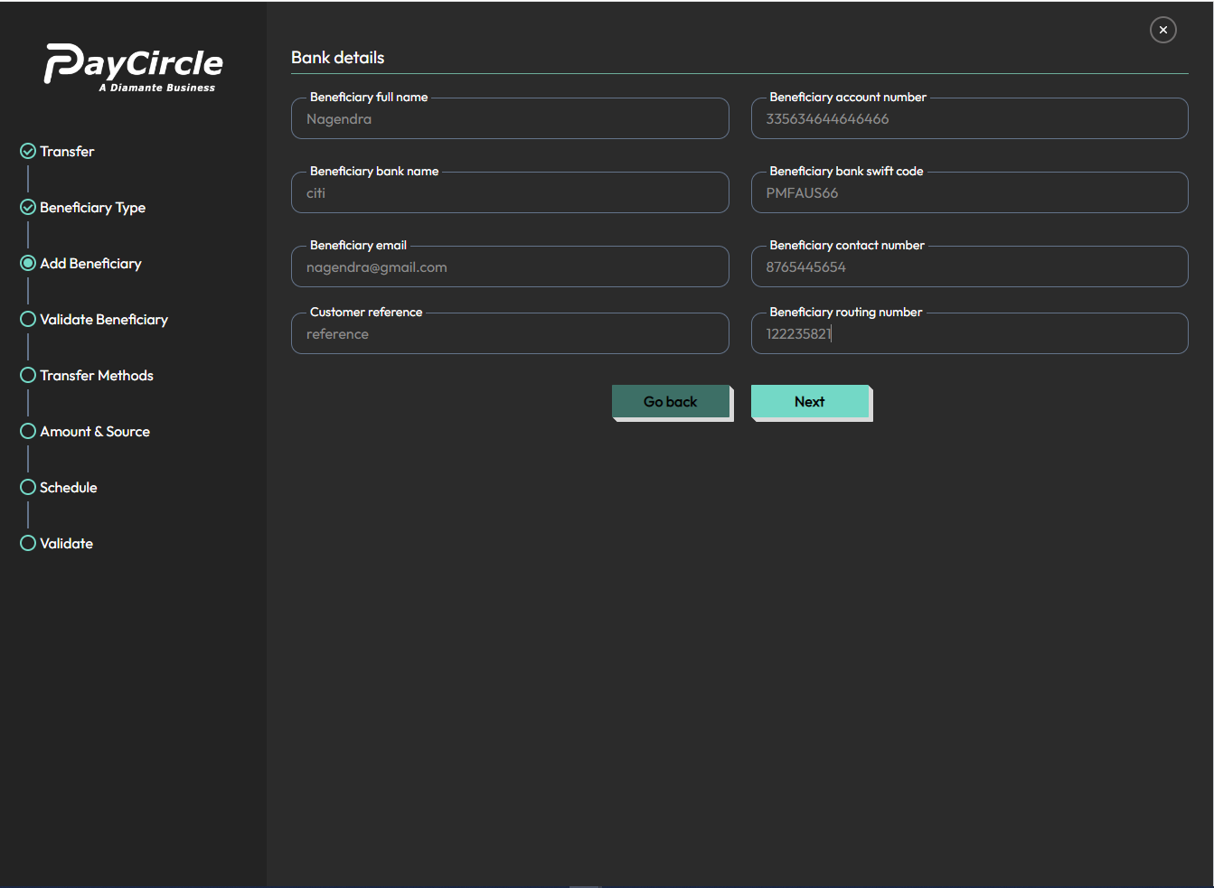
- After clicking, the next user has to enter receiver’s/beneficiary bank details and click on Next button.

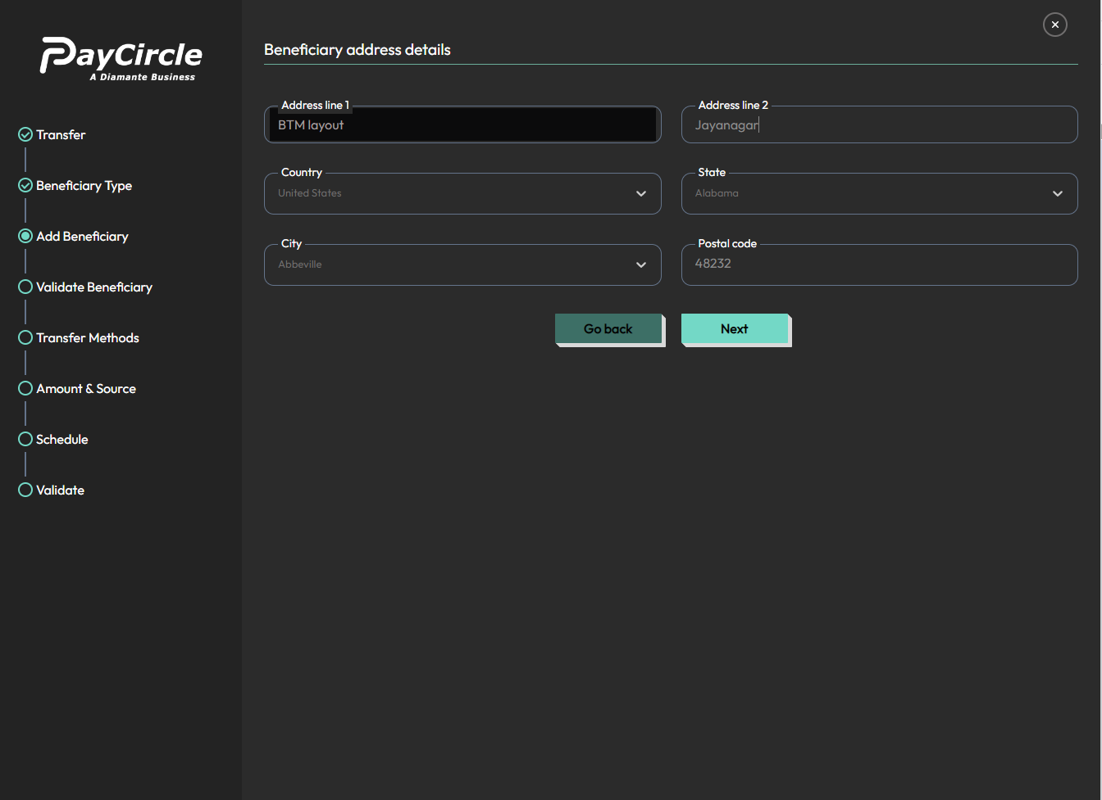
- After clicking next, the user has to enter receiver’s/beneficiary address details and click on Next button.

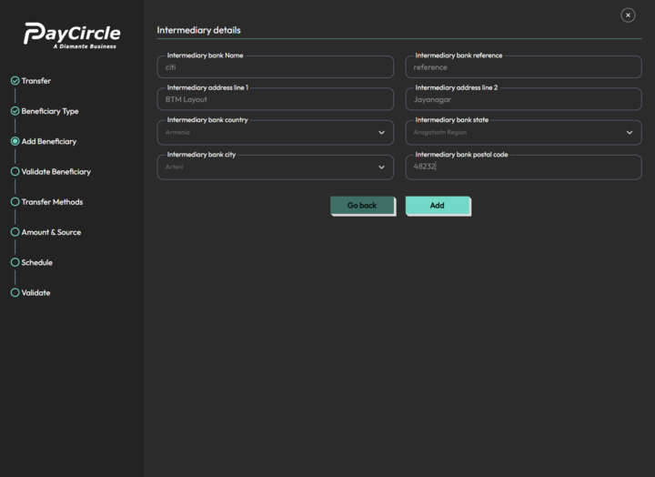
- The user then has to enter receiver’s/beneficiary Intermediary details and click on Add button.

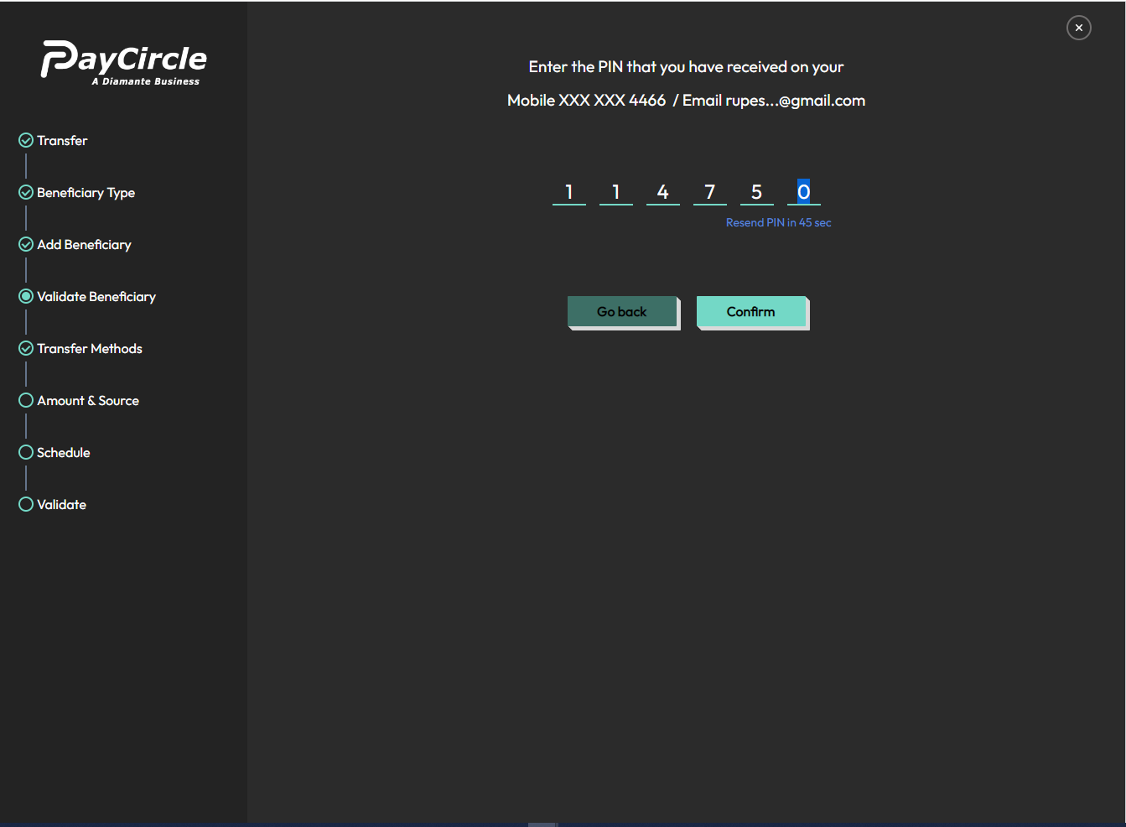

- After clicking Add, payment/v1/add-customer-beneficiary API is called to verify the beneficiary details to add.

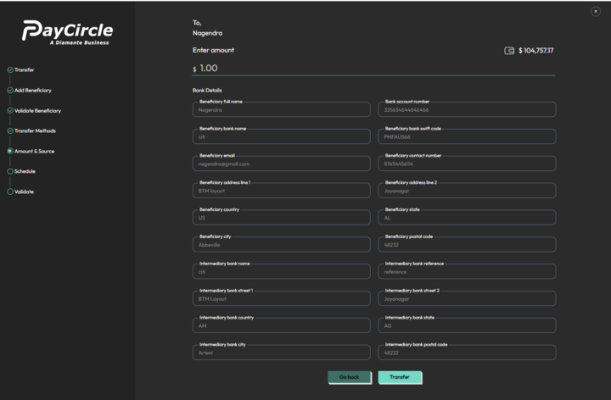
- After verification of the pin, the next screen is displayed to verify beneficiary details & enter the amount to be transferred & click on transfer button.
- After Clicking on the Transfer button users get the option to either pay Now or Schedule the payment.

Now
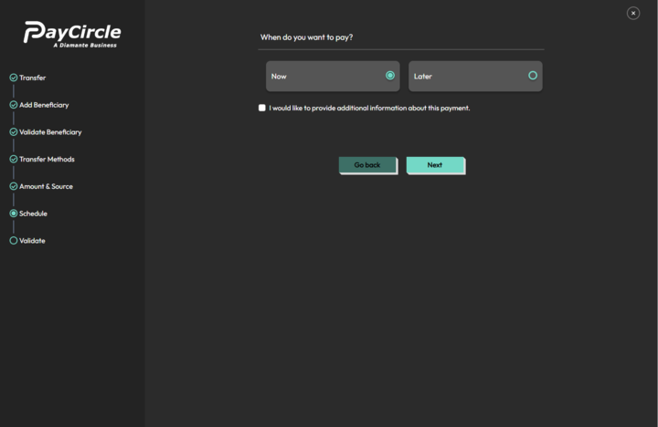

  - Case I: If user chooses to pay Now then they will be redirected to One-time-pin verification screen payment/v1/verifyTransOtp API will be called.

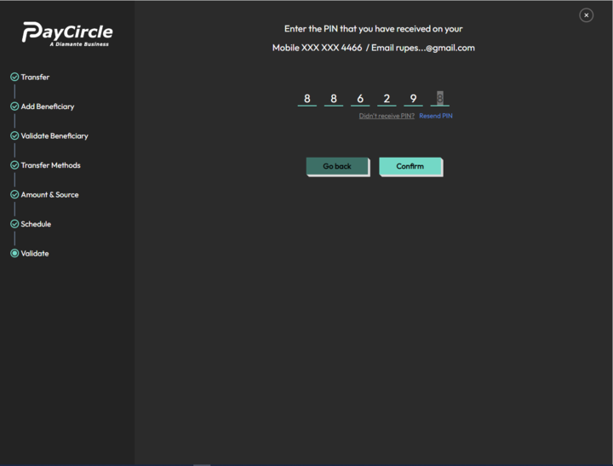
  - After entering the valid Pin & Click on confirm button then payment/v1/withdraw-funds API will be called.

Later
  - Case II: If the user wishes to schedule payment then they have to select the Later option.
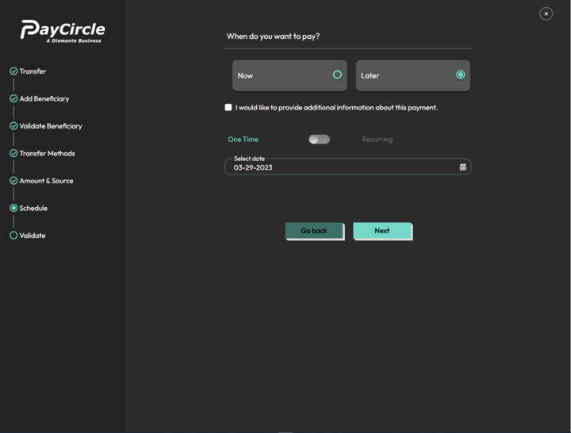

One-Time Schedule Payment

    - Case i: By default one-time payment is selected. In this user has to select the date on which they have to schedule the transaction and click on next they will be redirected to verify one-time-pin screen & payment/v1/verifyTransOtp API will be called.
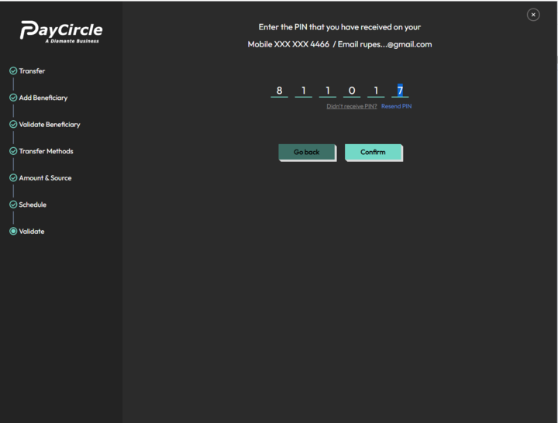
    - After entering a valid PIN, payment/v1/customer-schedule-fund-transaction will be called.


Recurring Schedule Payment
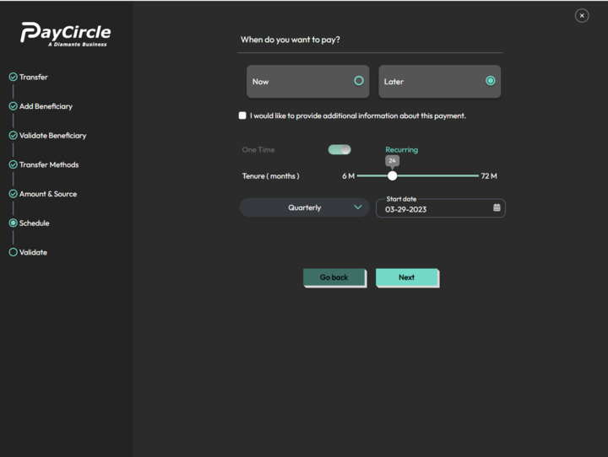
    - Case ii: If the user wishes to schedule recurring payment then they have to select Tenure, Payment Cycle & Start Date. After selecting all the payment details & click on next user will be redirected for verification of one-time-pin & payment/v1/verifyTransOtp API will be called.

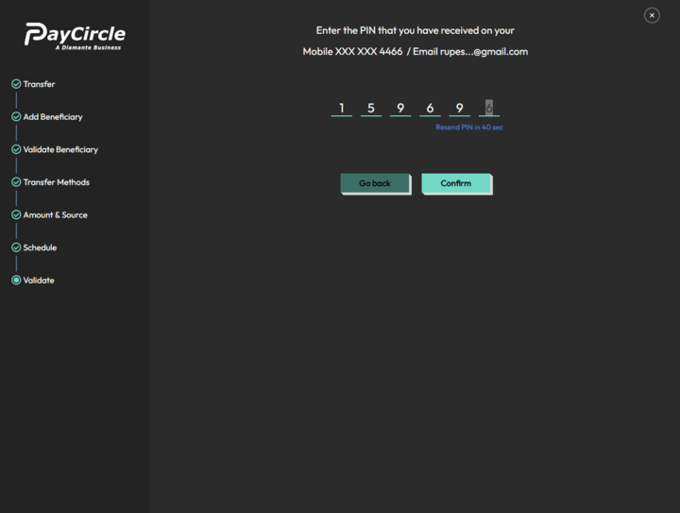
    - After entering a valid one-time-PIN, payment/v1/customer-schedule-fund-transaction API will be called.



Withdraw

Withdraw for ACH

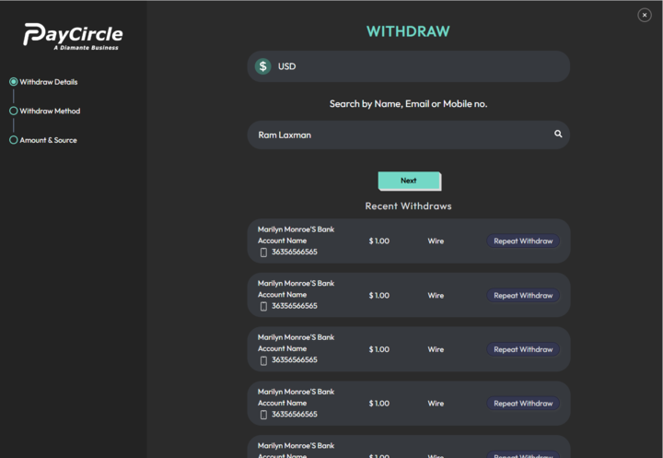

- By default, USD is selected for withdrawal and the user has to search/enter the receiver's name/email/mobile number.

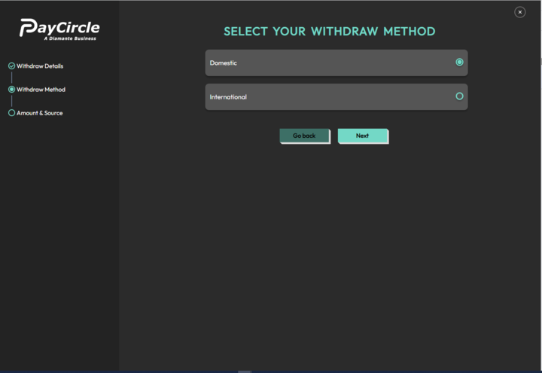
- The user selects Domestic and clicks on Next.

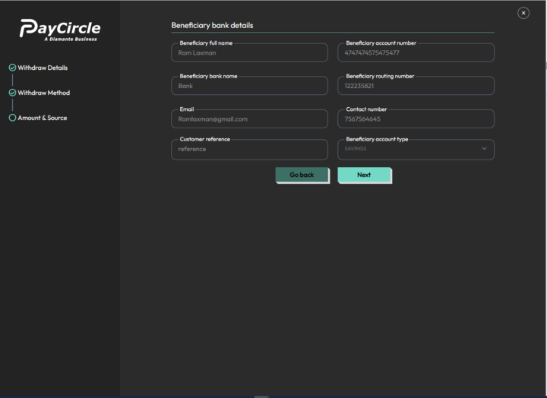
- The user enters the beneficiary/receiver's bank details and clicks on Next.

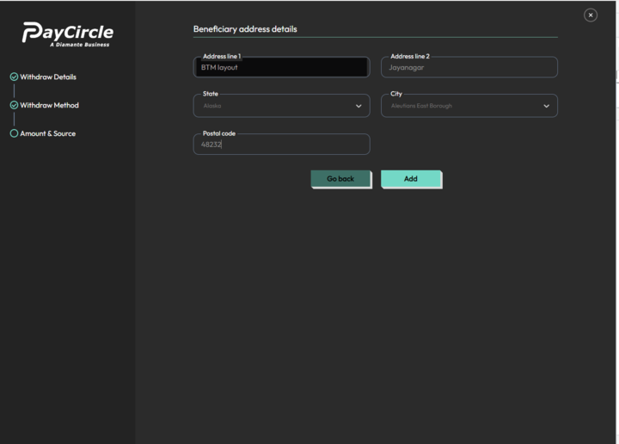

- The user enters the receiver's address details and clicks on the Add button. After entering all the details, the user is redirected to a one-time-pin verification screen for adding the beneficiary and the payment/v1/add-customer-beneficiary API will be called.

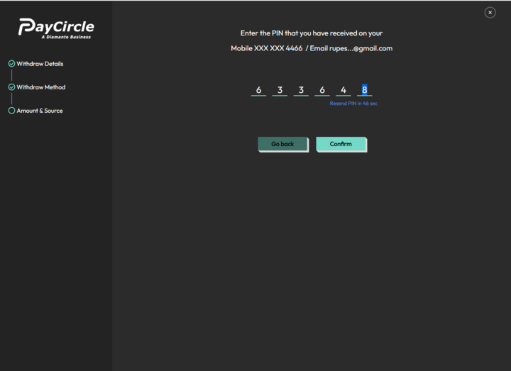
- After entering a valid pin and clicking on confirm, the payment/v1/get-beneficiary-details/{customerId}/{beneficiaryId} API will be called.

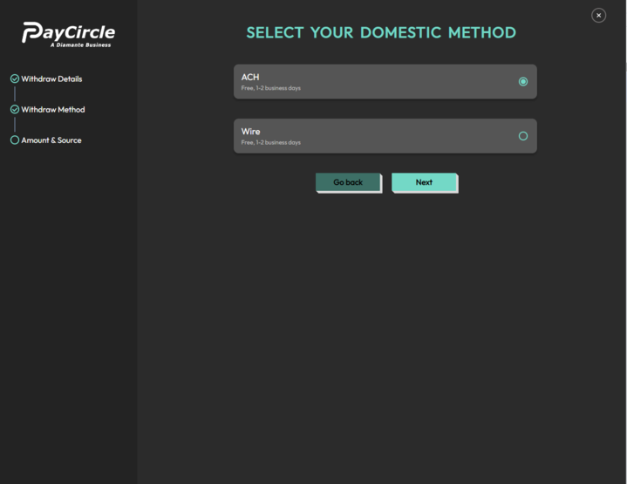
- After adding a beneficiary, the user gets the option to select a withdrawal method, either ACH or Wire.



  - Case i : If the user selects the ACH method and clicks on Next.

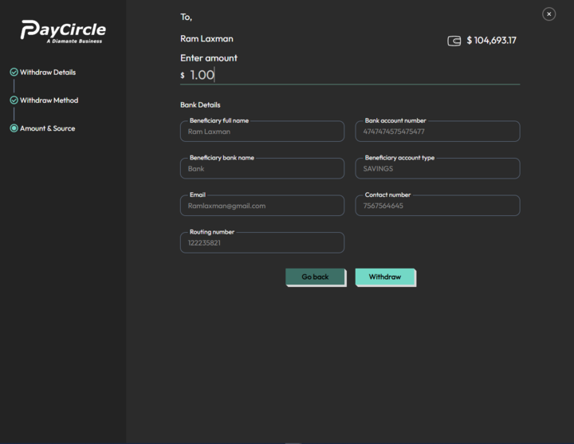
  - They then need to enter the amount and verify the receiver's details before clicking on Withdraw. The user will then be redirected to the one-time-pin verification screen and the payment/v1/verifyTransOtp API will be called..

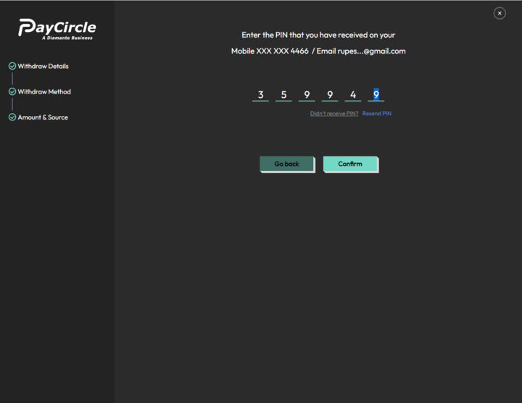

  - After entering a valid pin, the payment/v1/withdraw-funds API will be called.



Withdraw for Wire

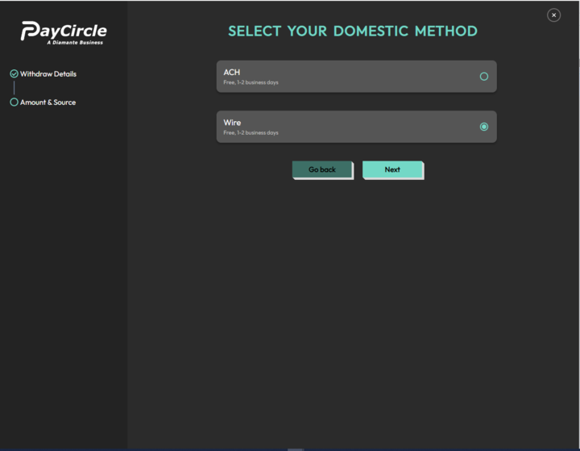

  - Case ii: When the user selects the Wire transfer method and clicks on the next button, they will see a screen where they have to enter the amount and verify the receiver details.

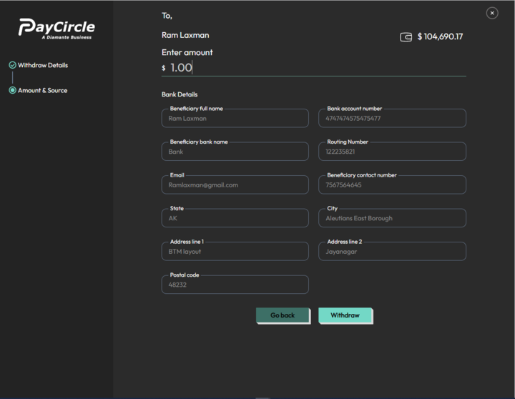
  - After that, they need to click on the Withdraw button, which will redirect them to the one-time-pin verification screen, and the payment/v1/verifyTransOtp API will be called.

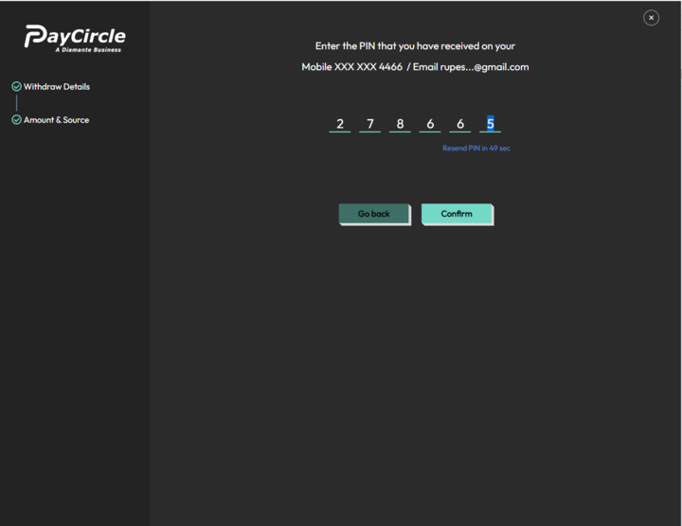

  - Once the user enters a valid Pin and clicks on Confirm, the payment/v1/withdraw-funds API will be called to complete the transaction.



Withdraw for International Wire

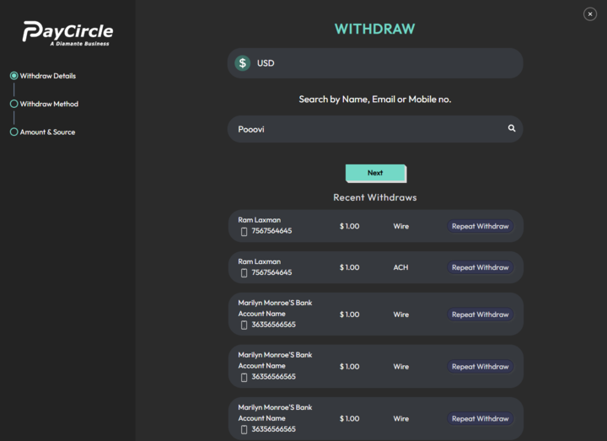

- By default, the asset is USD and the user needs to search or enter the beneficiary/receiver's Name/Email/Mobile No. and click on the Next button.

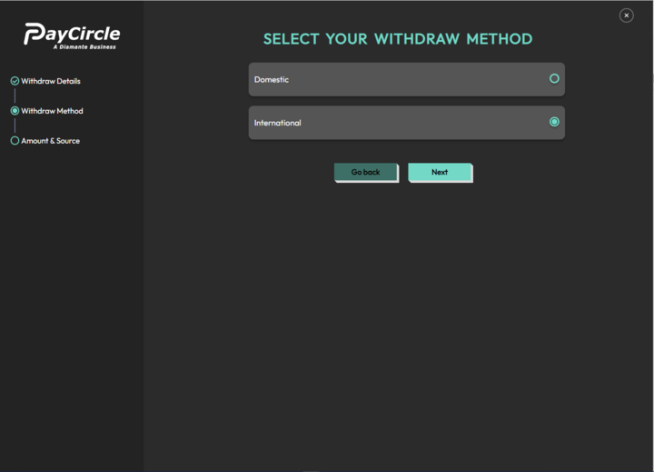
- The user needs to select the International Wire transfer method and click on the Next button.

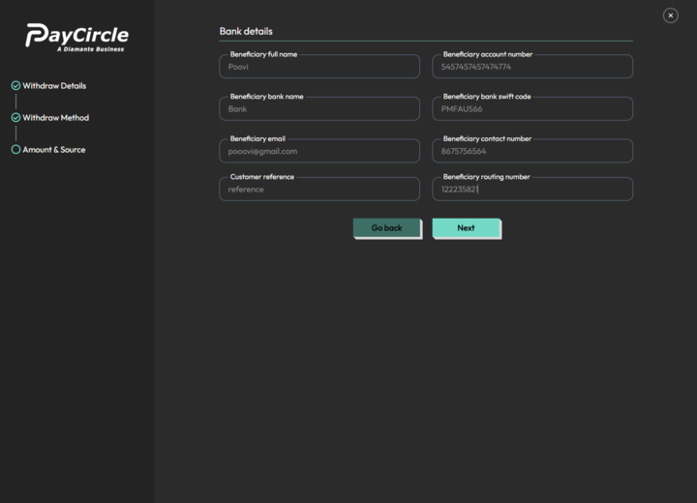

- In the next screen, the user needs to enter the receiver bank details and click on the Next button.

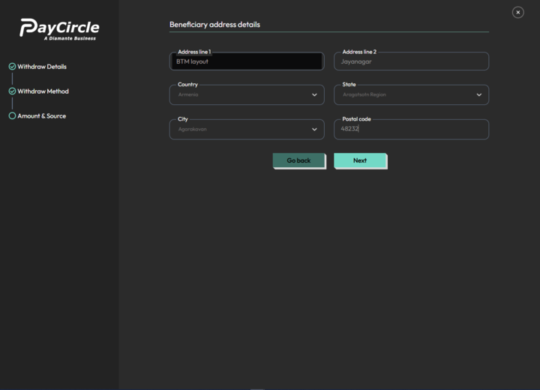
- In the following screen, the user needs to enter the receiver's address details.

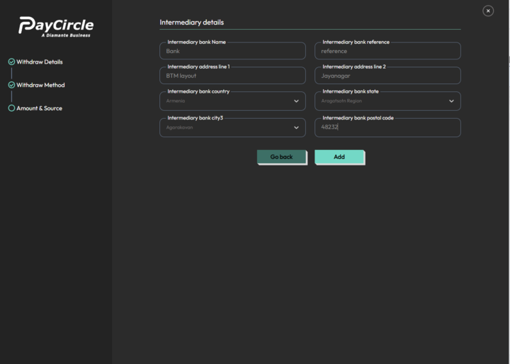
- In the same screen, the user needs to enter intermediary details and click on the Add button. After clicking on Add, the user will be redirected to a one-time-pin verification screen, and the payment/v1/add-customer-beneficiary API will be called.

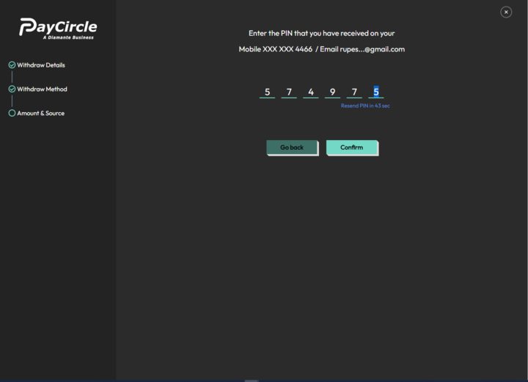
- After entering a valid pin, the payment/v1/get-beneficiary-details/{customerId}/{beneficiaryId} API will be called.

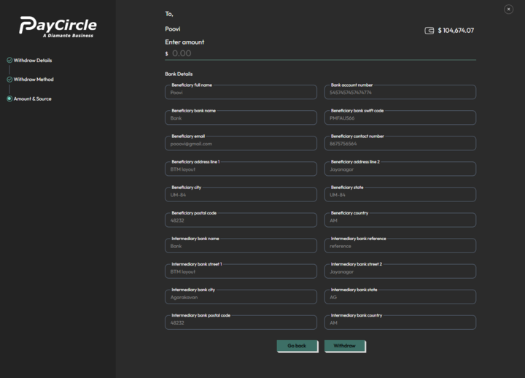

- After adding the beneficiary, the user gets the screen to add the amount and verify the receiver's details, and after that, click on the withdraw button. The user will be redirected to verify the one-time-pin, and the payment/v1/verifyTransOtp API will be called.
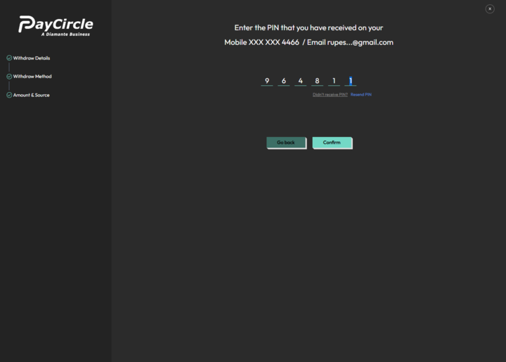

- After entering the valid pin & click on Confirm button. payment/v1/withdraw-funds API will be called.



Trade - Buy

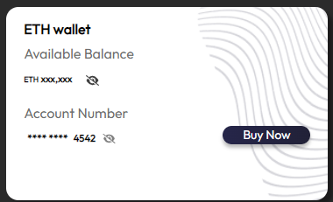

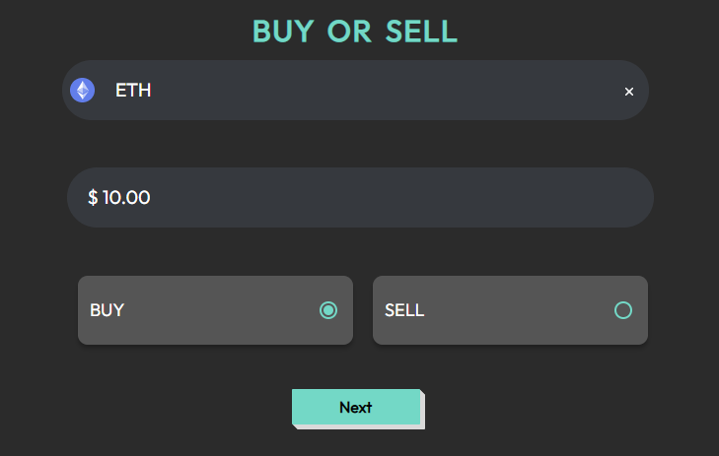

- When you enter the name of the asset you want to buy, the system will call the v1/get-asset-details/ETH/Trade API and automatically convert the amount to USD. After clicking on the Buy button, the v1/get-wallet-details/{customerId}/{assetId} API will be called. Clicking on Next will trigger a call to the v1/generate-quote API.

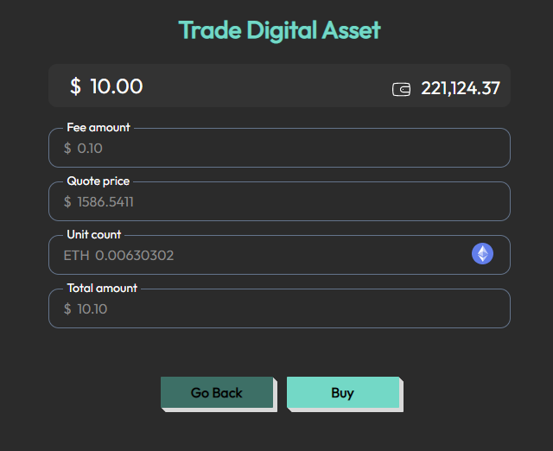

- Once the v1/generate-quote API is called, the system will provide you with details such as the fee amount, quote price, unit count, and total amount. If you agree to the quote, clicking on the Buy button will call the v1/execute-quote API and execute the trade, completing the process successfully.



Trade - Sell

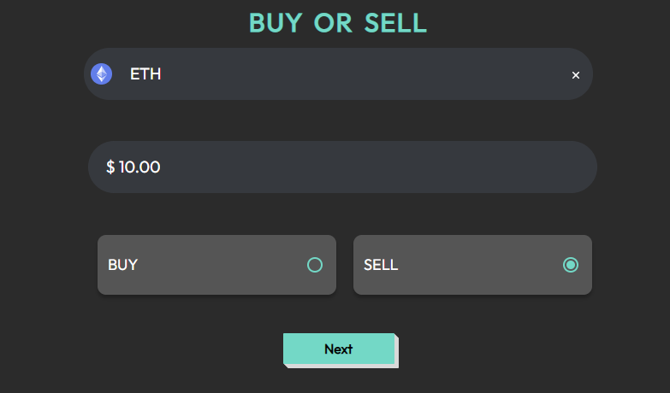

- When the user enters the asset name for selling, it will call the v1/get-asset-details/ETH/Trade API and the amount will be converted to USD. When the user clicks on Sell, it will call the v1/get-wallet-details/{customerId}/{assetId} API. After clicking Next, the v1/generate-quote API will be called.

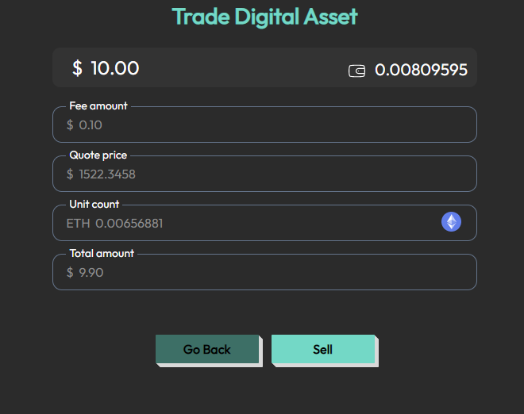

- After calling the v1/generate-quote API, it will provide the fee amount, quote price, unit count, and total amount. When the user clicks on Sell, it will call the v1/execute-quote API, and the trade will be successful.



Transaction History

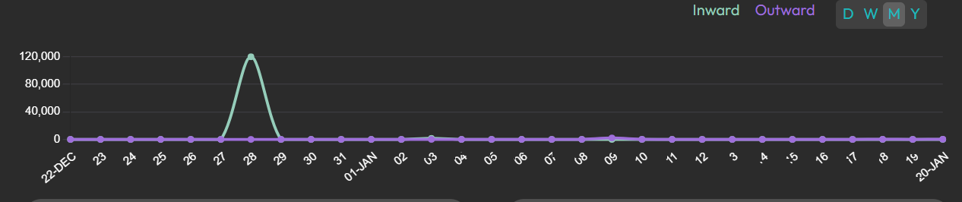

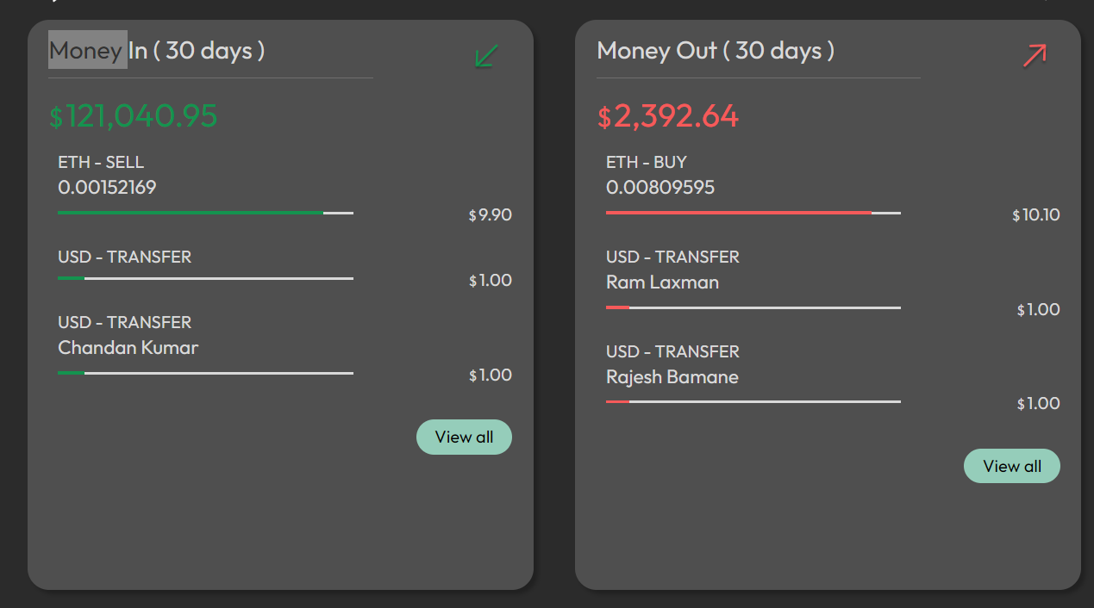
- When the user clicks on "View All" in the transaction history section, it will redirect to the transaction history page. For Fiat currency, all transactions, including deposits, withdrawals, transfers, and all, are referred to as v1/get-transaction-history-by-type API.
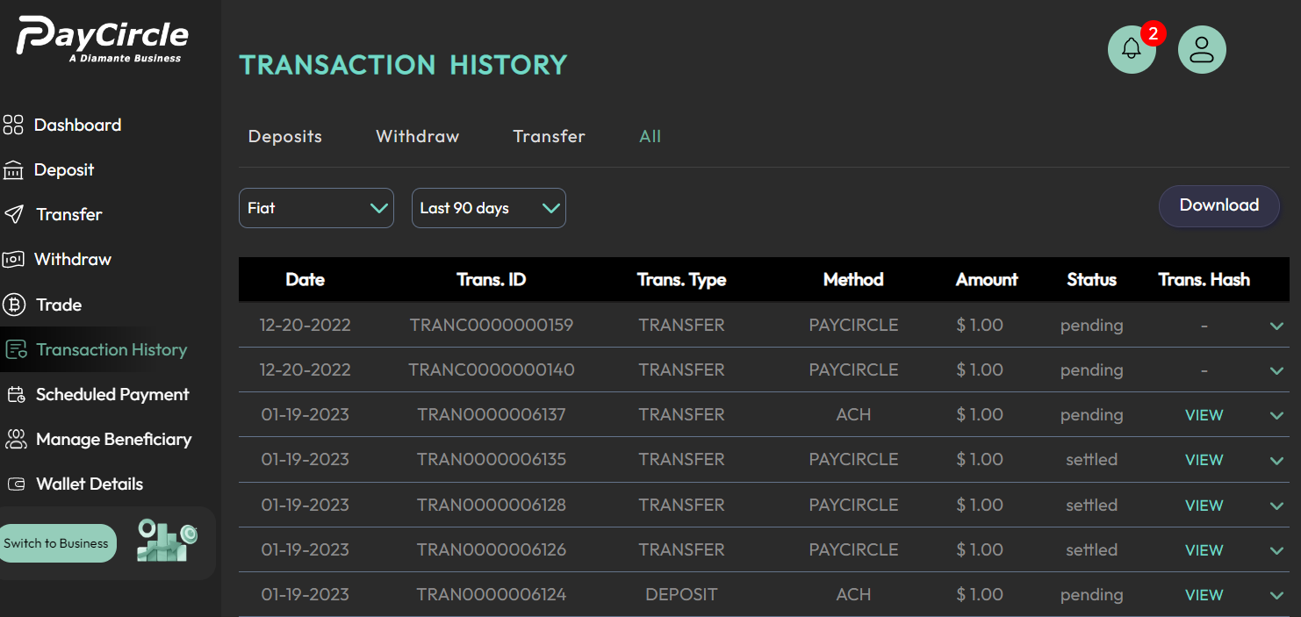

- Similarly, for cryptocurrencies, all transactions, including transfer, buy, sell, and all, are referred to as the same API v1/get-transaction-history-by-type.

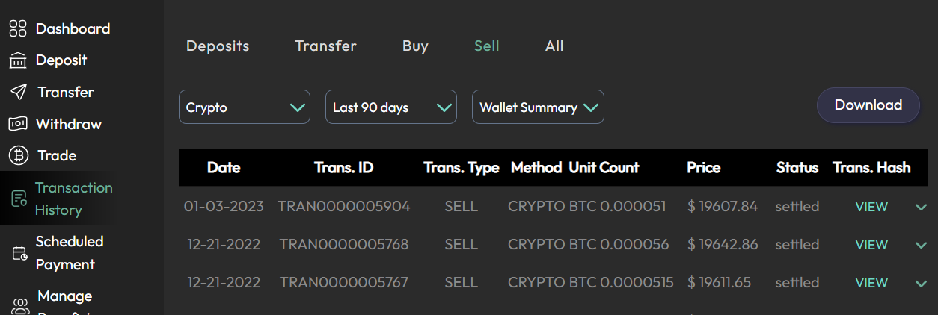

- If the user clicks the "Download" button for either Fiat or Crypto, the /v1/get-transaction-history-by-type-pdf API is called, which downloads a PDF file with the transaction data.
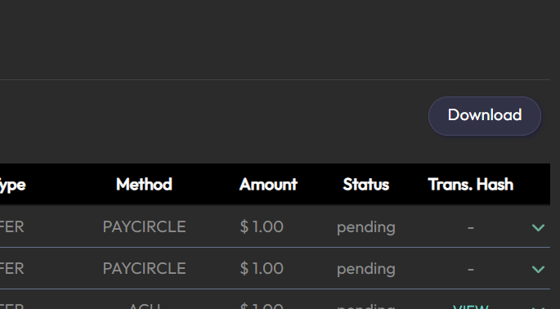

Scheduled Payments

- When a user selects a checkbox for Scheduled Payments to modify the days to "last 90 days," "last 70 days," or "custom," the v1/customer-schedule-payment-list API is called to retrieve the relevant payment details.

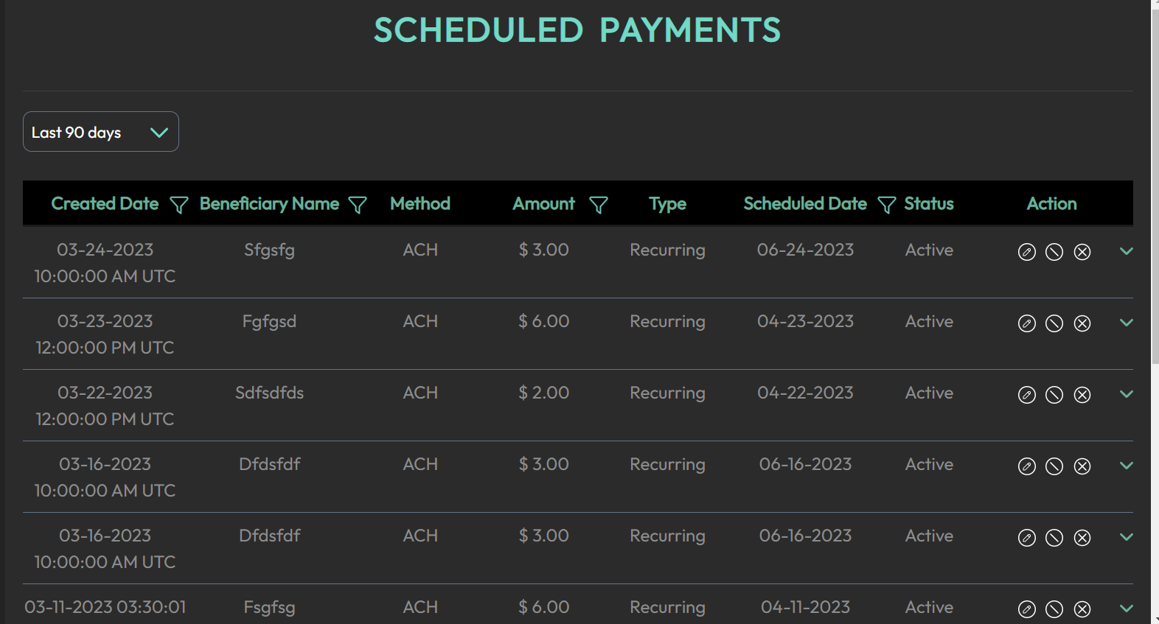

- If the user wishes to delete any of the scheduled payments from the list, they can call the v1/customer-delete-schedule-payment API.

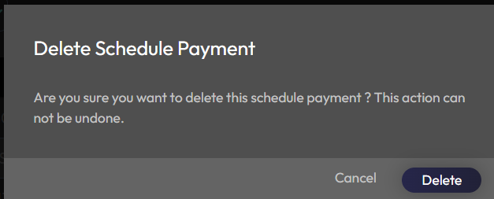

Manage Beneficiary

- To add a new beneficiary for ACH or wire transfer, click "Add new beneficiary" and provide bank details, then click "ADD".
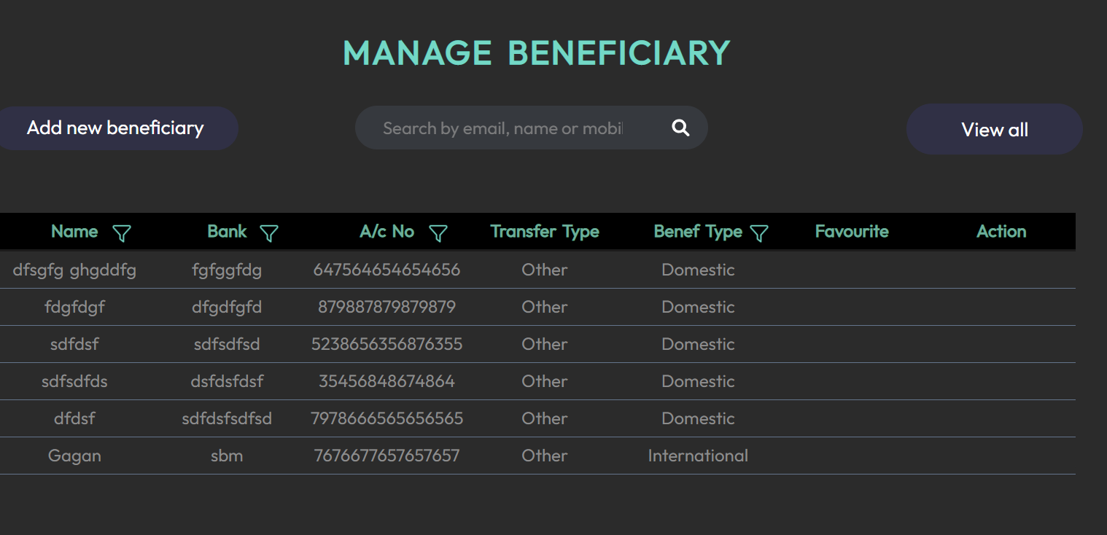

- This calls the v1/add-customer-beneficiary API, which works for both domestic and international wire transfers.
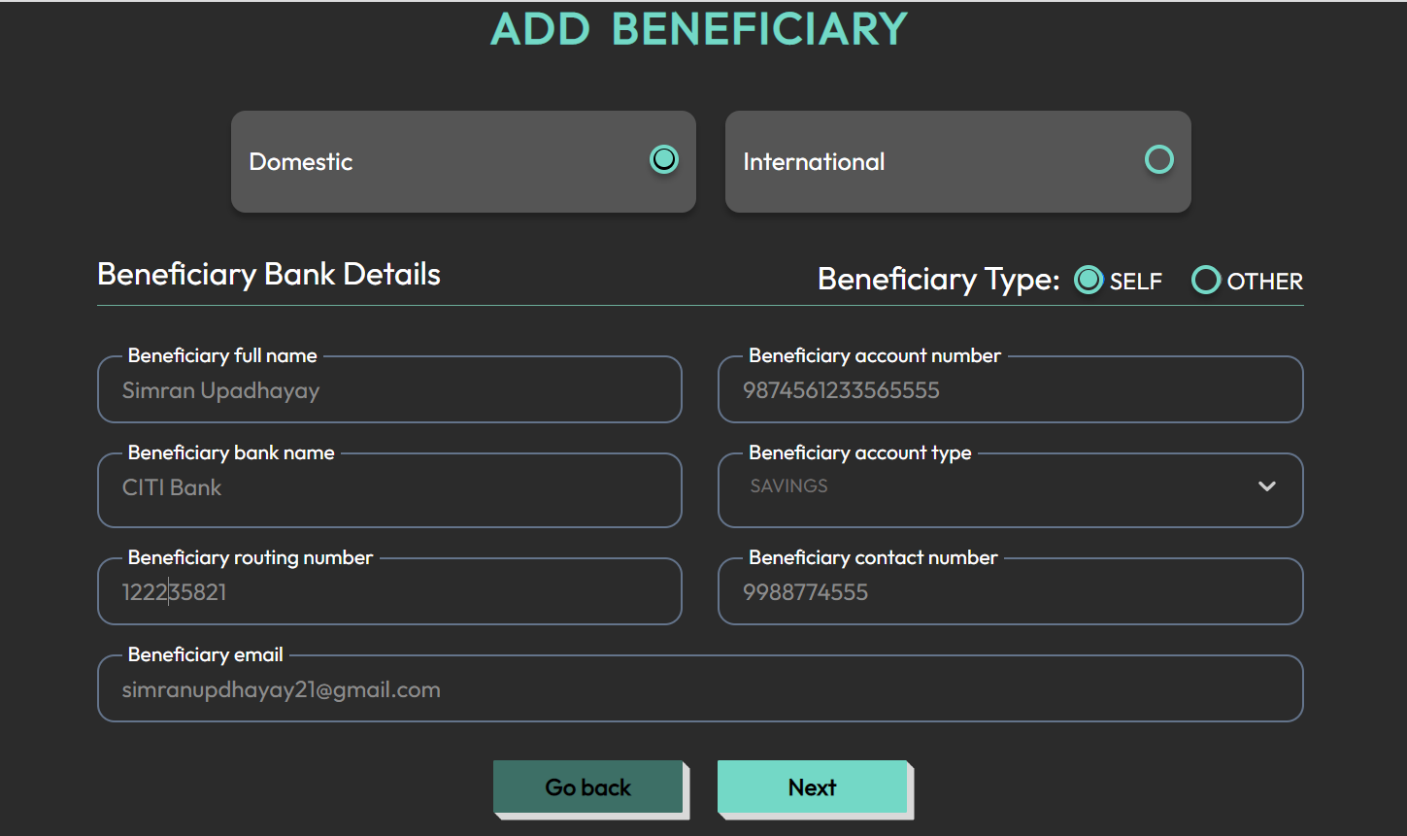

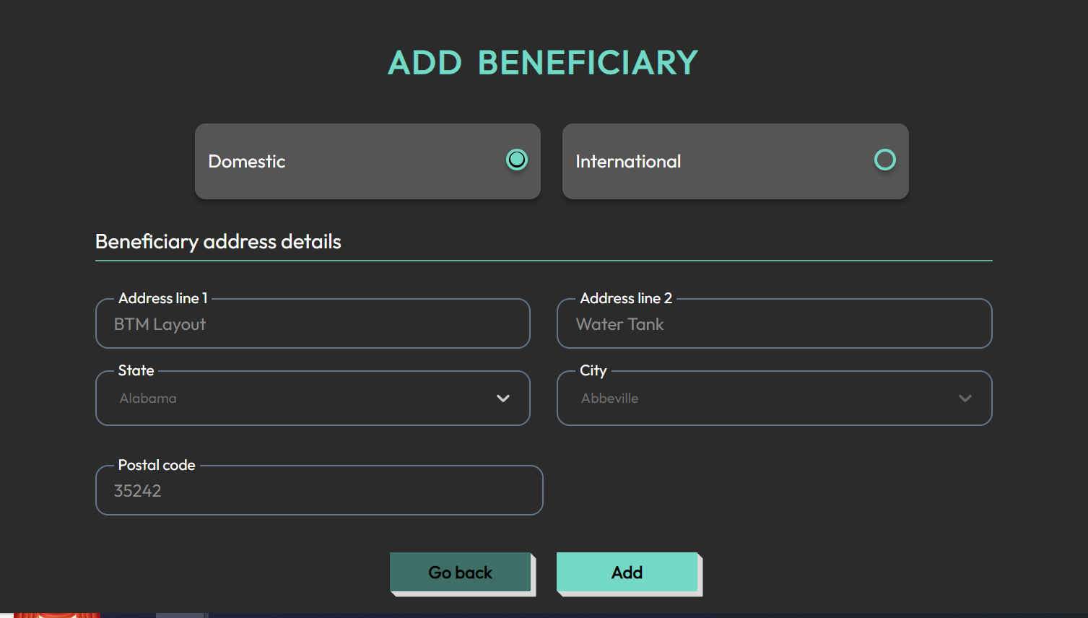

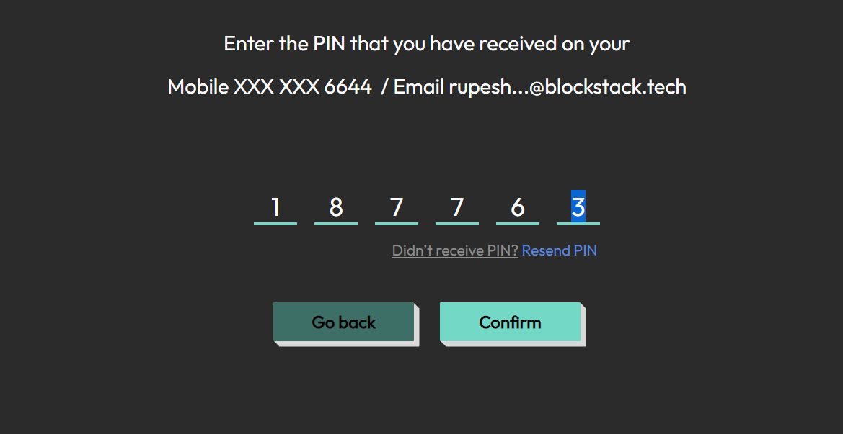

- To search for an existing beneficiary, use the search bar and enter the beneficiary's email. This calls the v1/get-customer-beneficiary-details API.

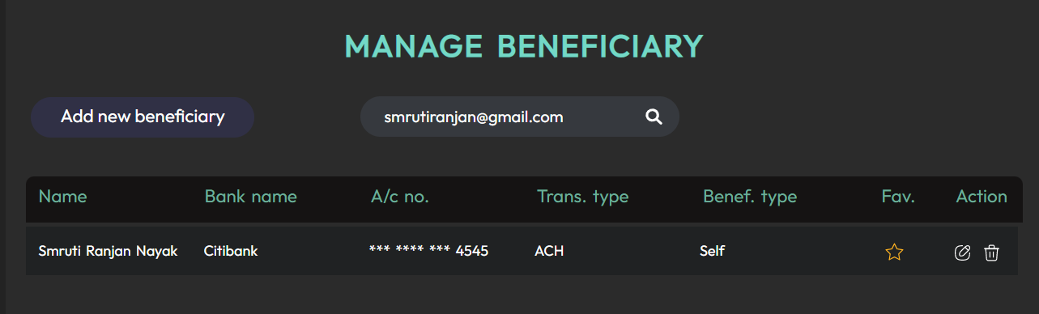

- To delete a beneficiary, use the delete option for the corresponding beneficiary. This calls the v1/delete-customer-beneficiary-details API.

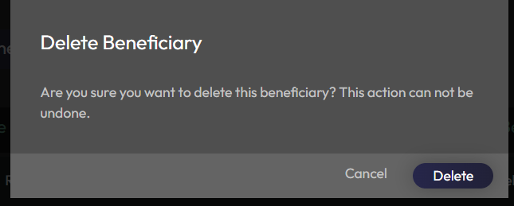

Wallet Details

The wallet displays information regarding the Account Number and the Available Balance

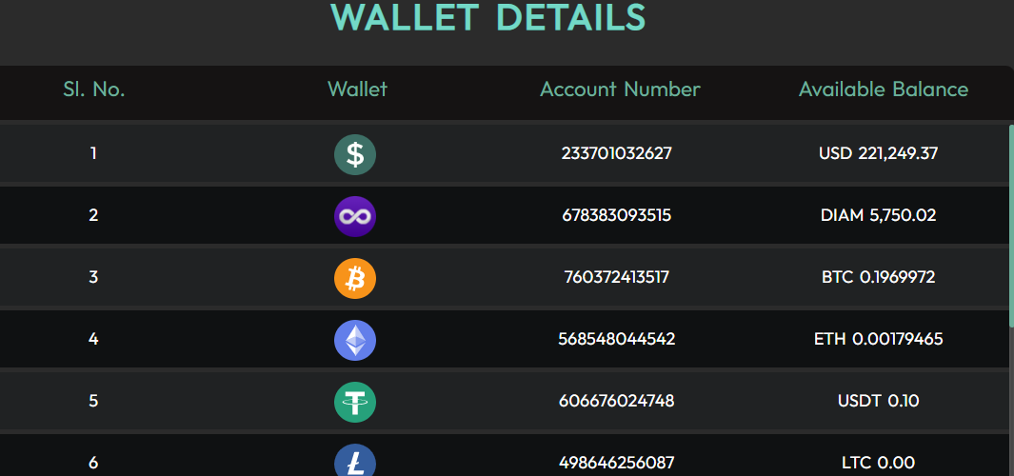

Dashboard

Settings

- Clicking on "Settings" and then "Linked Bank" triggers a call to the /bank/get-bank-details/{customerId} API.
- Clicking on "Add bank account" internally calls the Plaid API /bank/createLinkToken.

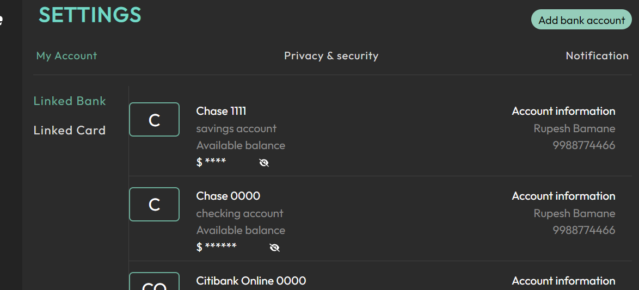

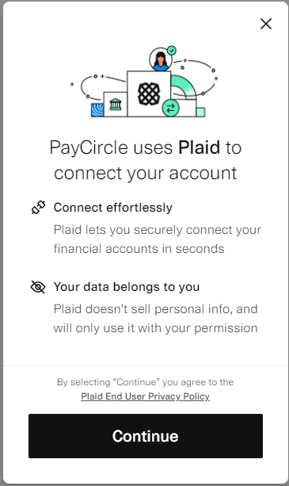

- After clicking on the "Continue" button on the Plaid terms and conditions page, the user selects their bank.

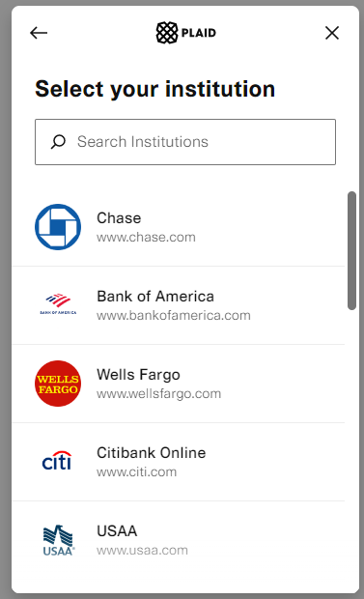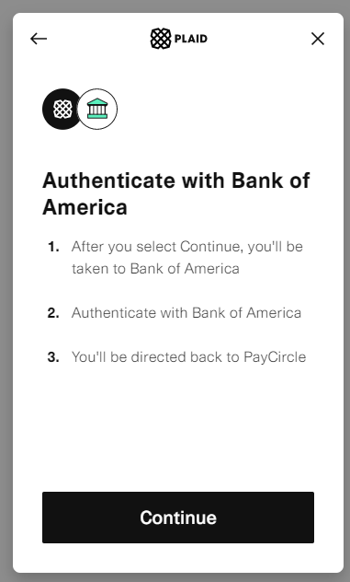

- The user then signs in using their bank credentials and enters the OTP received on their registered mobile number.

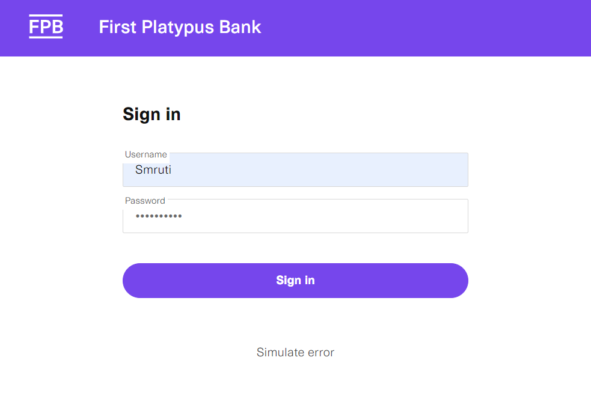

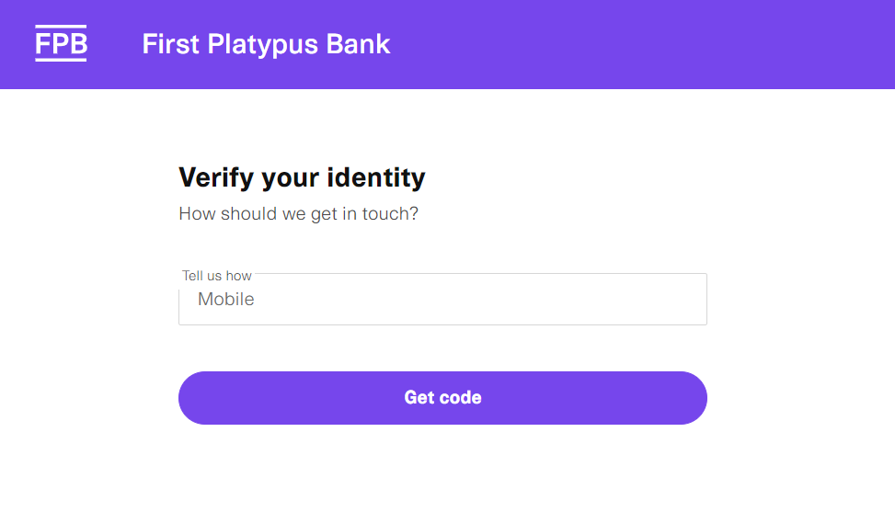
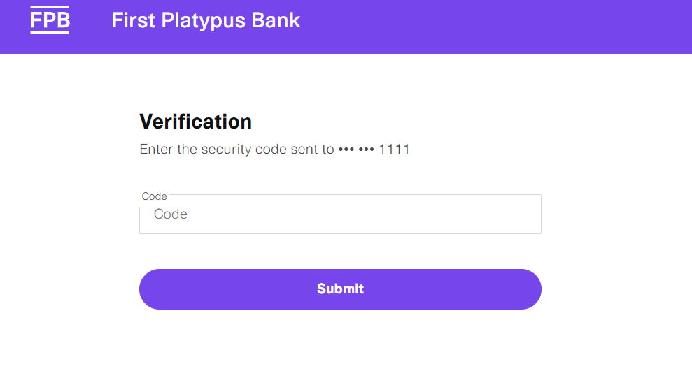

- After verifying the OTP, the user selects the bank account type and clicks "Continue," which calls /bank/getAccessToken.

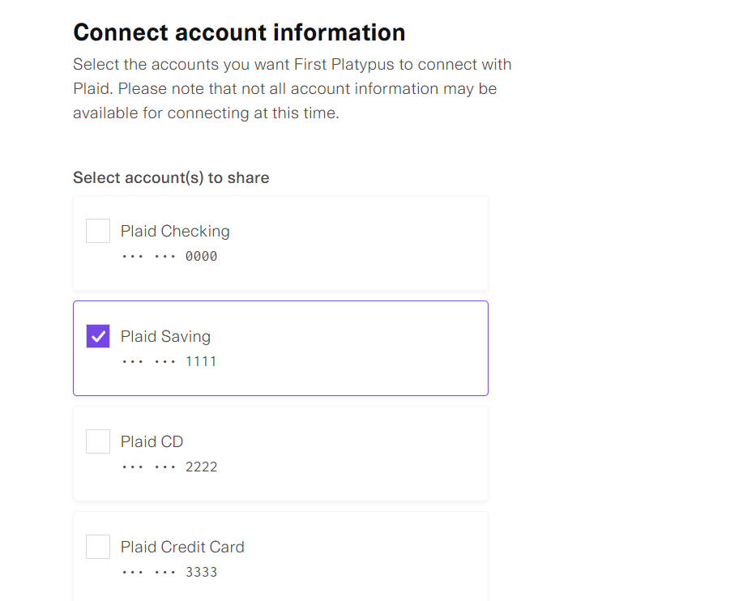

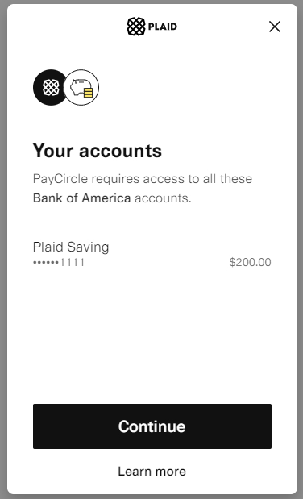

- Once the bank link process is completed, the user gets a success screen where they can click "Continue" and deposit funds from the newly linked bank.

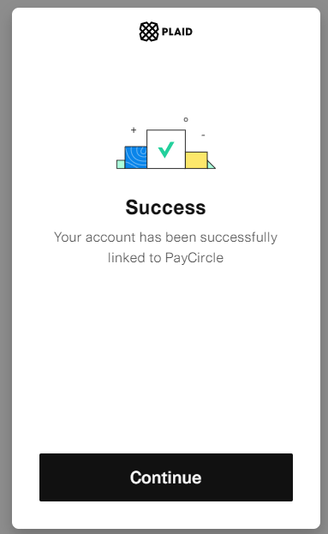
- Clicking on "Privacy & security" triggers a call to the /account/v1/sign-in/login-history/{customerId} API.
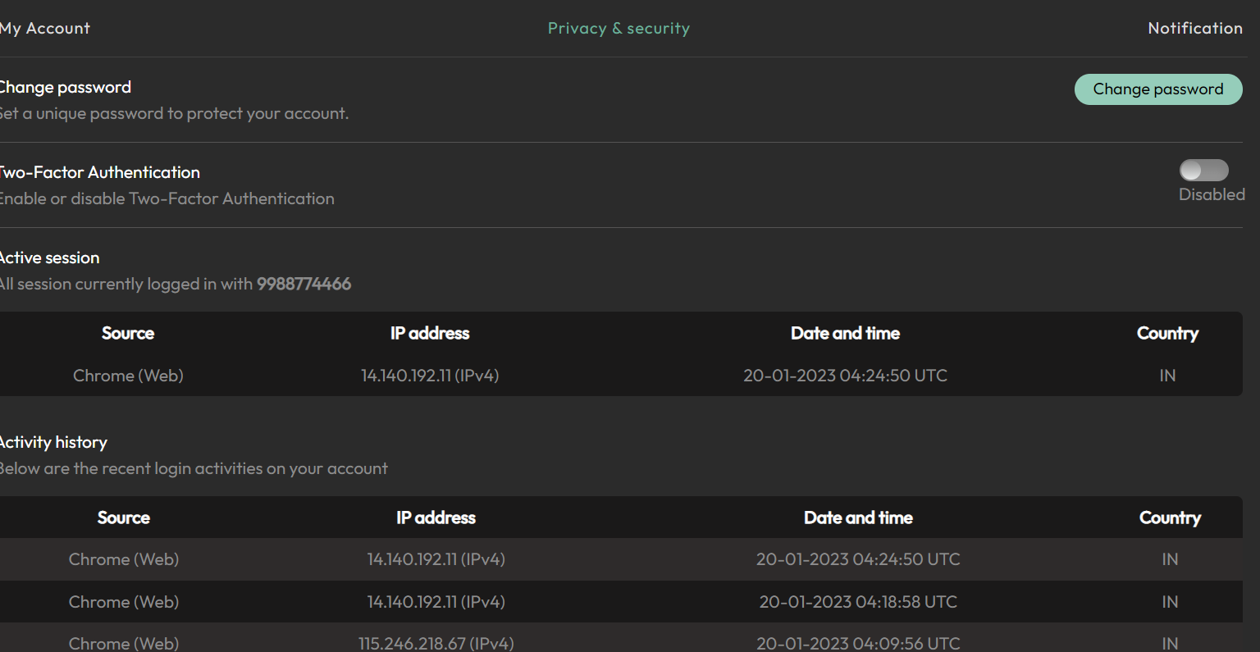

- Clicking on "Change password" triggers a call to the /account/v1/user-details/change-credential API.

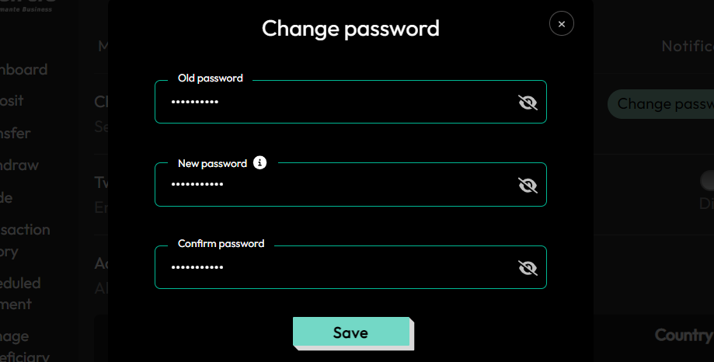

- Clicking on "Notification" triggers a call to the /account/v1/get-customer-notification-details/{customerId} API.
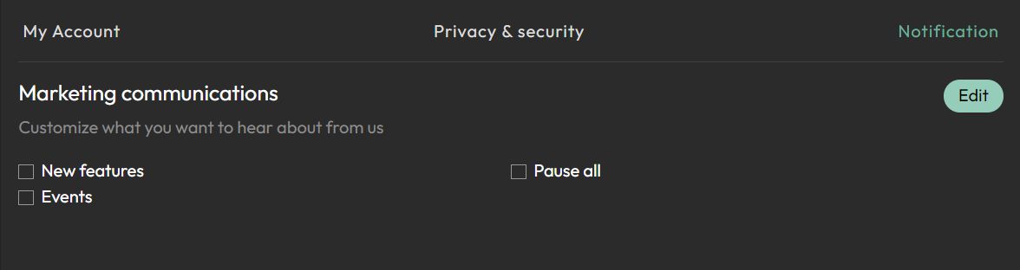

- Clicking "Edit" to update notifications triggers a call to the /account/v1/insert-customer-notification API.

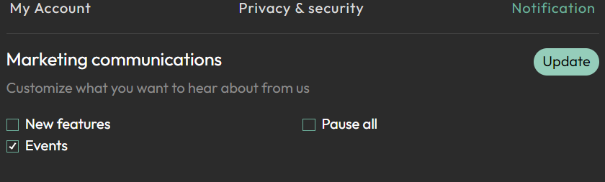

- Clicking on "Linked Card" triggers a call to the /bank/get-credit-card-details/{customerId} API.

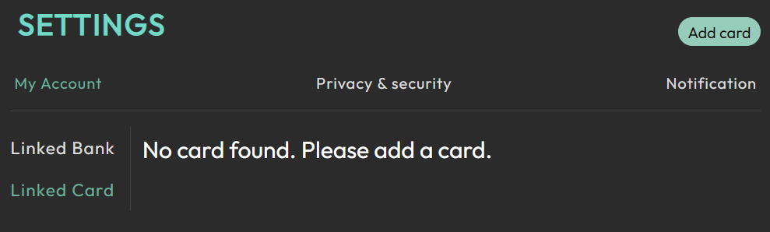

- Clicking on "Add Card" triggers a call to the /bank/credit-card-resources/customerId API.
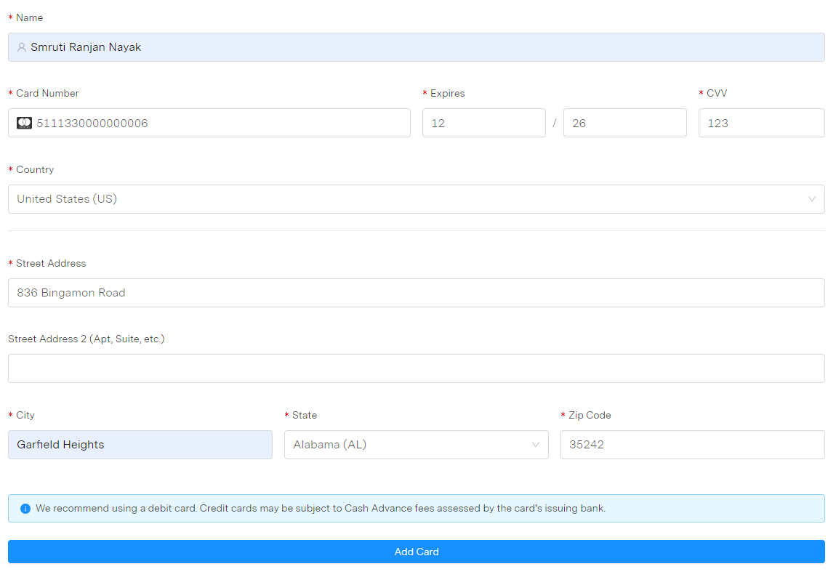

- Adding a credit card triggers a call to the /bank/insert-credit-card-details/{customerId} API.



Support

When you click on "Support," you will be prompted to provide your information, such as name, email, and message. After providing this information, you can click on "Submit." This will trigger a call to the /account/v1/support-mail API, which will send your message to the support team for review and response.

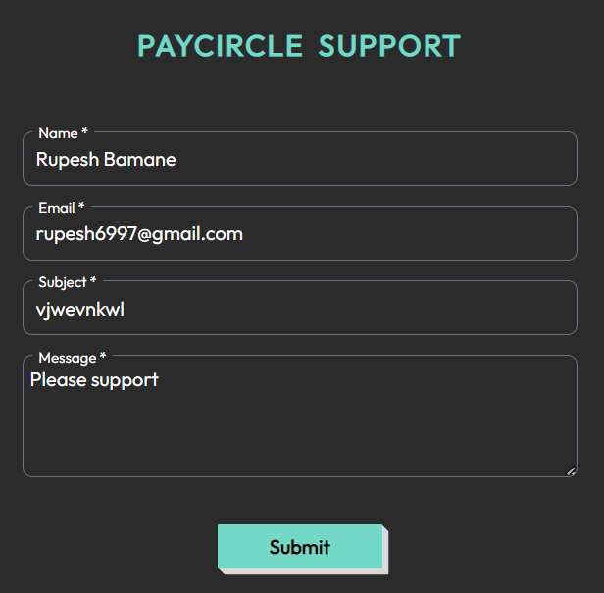

Notifications

When you click on the "Notifications" tab, it triggers a call to the /account/v1/customer-alert-settings API. This API allows you to manage and customize your notification settings, such as setting up alerts for account activity, balance updates, and other important events.

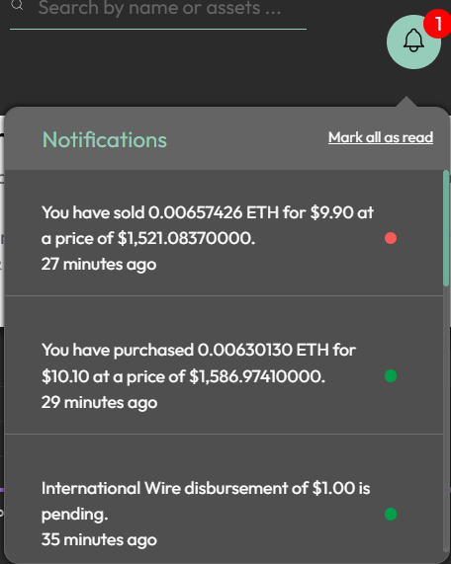

Profile

- Click the ‘profile’ button to view the profile details. This will call the /account/v1/get-profile-details/{customerId} API.

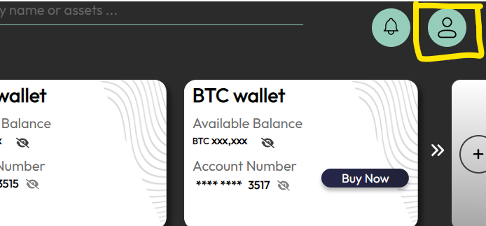
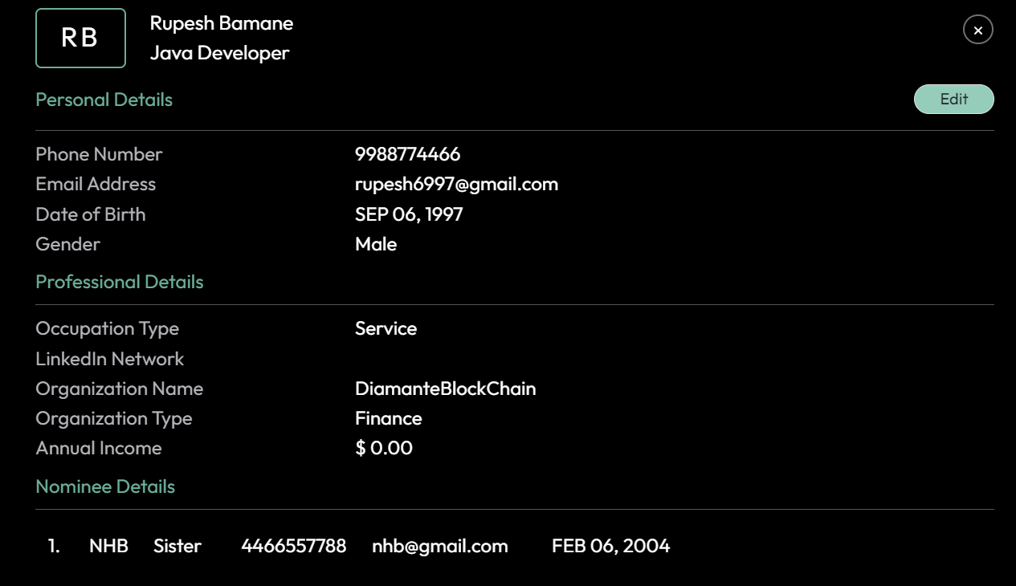

- Click the ‘Edit’ button to modify personal information, and then click ‘Next’. This will call the /account/v1/get-customer-details/{customerId} API.
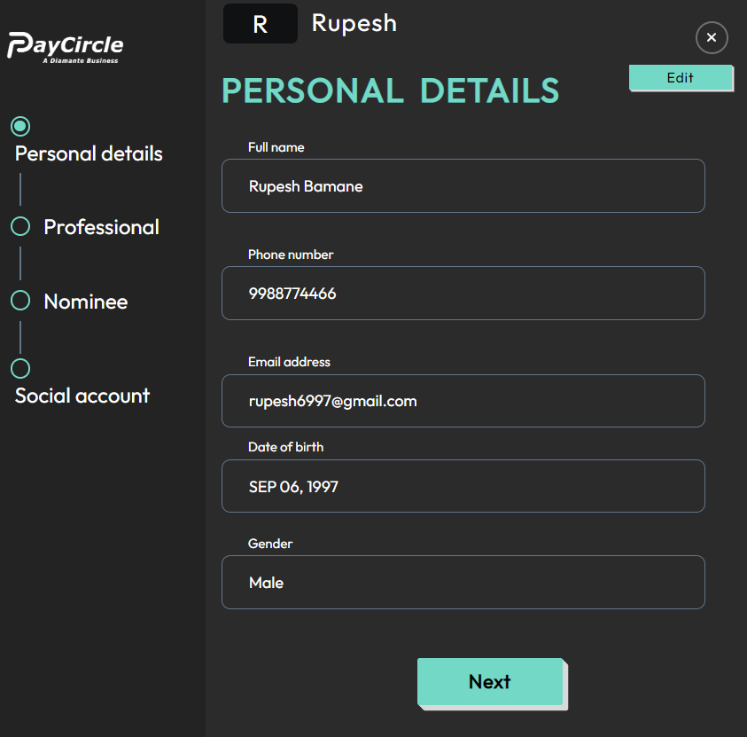

- Click ‘Next’ to provide professional details, and then click ‘Edit’. This will call the /account/v1/profile/professional-details/{customerId} API.

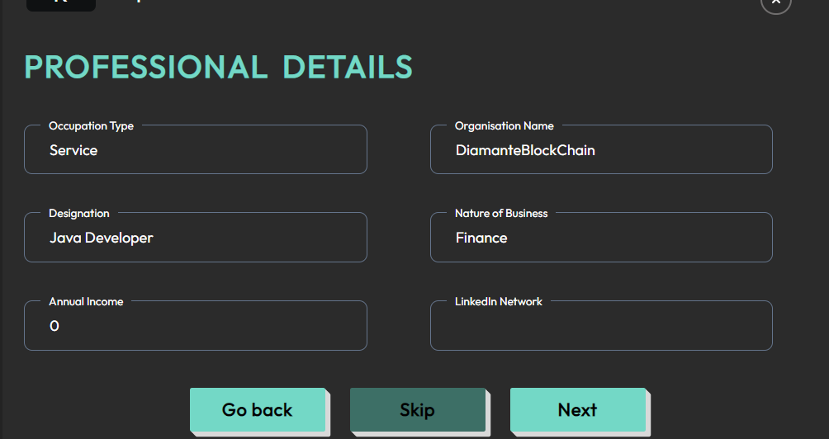

- Click ‘Next’ to add nominee details, and then click ‘Add’. This will call the /account/v1/profile/family-details/{customerId} API.

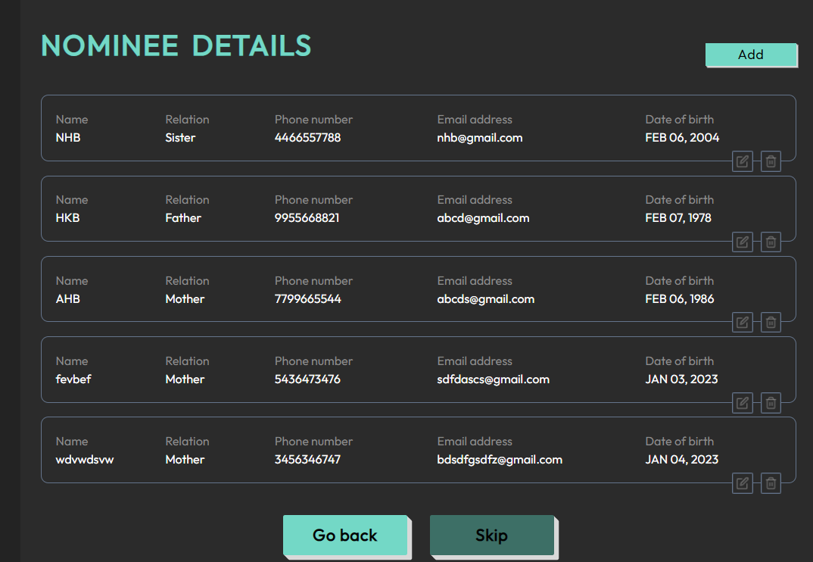

- Click the delete button to remove nominee details. This will call the /account/v1/profile/delete-family-details API.
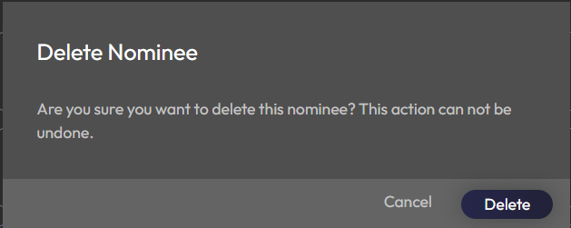

- Click ‘Social account’ and then ‘Edit’ to add social media information. This will call the /account/v1/profile/social-media-links/{customerId} API.

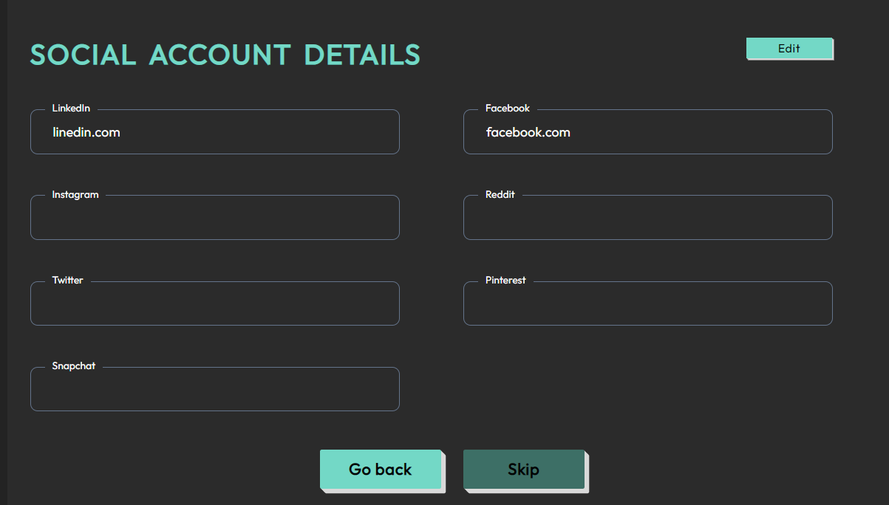

Dashboard Search

When the user searches by name or assets it will call /payment/v1/search-via-payee-asset/{customerId} API.
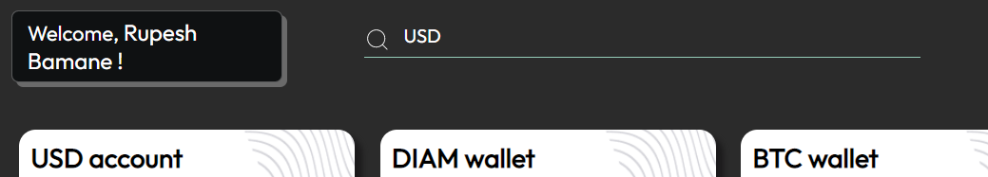

Logout

- When you decide to log out from the app, the /account/v1/logout-user API is called.
- This API is responsible for logging you out of your account and ending your session on the platform.
- Once the API is triggered, your login credentials and session data will be invalidated and you will be redirected to the login screen if you wish to sign in again.

